**CHAPTER 1**

**INTRODUCTION**

In the fast-paced and ever-changing landscape of today's world, we face a constant influx of decisions that inundate us with a multitude of choices daily. This phenomenon, referred to as "decision fatigue," arises from the overwhelming abundance of options available, spanning from selecting our evening meals to choosing books and films for leisure. This challenge is further intensified by the deluge of information characterizing our present era. Within this context, recommendation systems become essential tools. Crafted with careful precision, these systems mitigate decision fatigue by assisting users in identifying items, features, or products that resonate with their preferences and past interactions.

In today's digital age, where streaming platforms offer an overwhelming array of movies and TV shows, users often face the daunting task of deciding what to watch. Movie recommendation systems have emerged as indispensable tools to help users navigate this vast content landscape by providing personalized suggestions tailored to individual preferences. These systems leverage sophisticated algorithms and data analysis techniques to analyze user behavior, movie attributes, and other contextual information to deliver relevant recommendations. In this introduction, we will explore the importance of movie recommendation systems, their underlying principles, and the impact they have on user experience and engagement.

Movie recommendation systems serve as virtual curators, guiding users through the myriads of available content options to discover movies they are likely to enjoy. By analyzing user interactions such as ratings, reviews, watch history, and browsing behavior, these systems gain insights into individual preferences and patterns, allowing them to generate personalized recommendations. Moreover, movie recommendation systems take into account various factors such as movie genres, cast, directors, release dates, and popularity to offer diverse and relevant suggestions to users. This personalized approach not only helps users find movies that align with their tastes but also encourages exploration and discovery of new content they may not have otherwise considered.

At the heart of movie recommendation systems lie sophisticated algorithms that leverage machine learning, data mining, and artificial intelligence techniques to analyze vast amounts of data and make predictions about user preferences. Collaborative filtering algorithms, one of the foundational techniques used in recommendation systems, identify similarities between users or items based on their past interactions to generate recommendations. User-based collaborative filtering compares the preferences of similar users to suggest movies that one user might like based on the preferences of others with similar tastes. Item-based collaborative filtering, on the other hand, recommends movies similar to those the user has already liked or watched based on their characteristics.

Matrix factorization techniques such as Singular Value Decomposition (SVD) and Alternating Least Squares (ALS) are also commonly employed in recommendation systems to uncover latent factors underlying user-item interactions. These techniques decompose the user-item interaction matrix into lower-dimensional matrices, revealing hidden patterns or preferences that drive user behavior. Content-based filtering algorithms, meanwhile, analyze the attributes of movies and match them with user preferences to generate recommendations. By considering factors such as movie genres, cast, directors, and plot summaries, content-based filtering can recommend movies that share similar characteristics to those the user has expressed interest in.

In recent years, hybrid recommendation systems that combine collaborative filtering, content-based filtering, and other techniques have gained prominence for their ability to deliver more accurate and diverse recommendations. These hybrid models leverage the strengths of different recommendation approaches to overcome their individual limitations and provide more robust and personalized recommendations. For example, a hybrid model may use collaborative filtering to identify similar users and content-based filtering to fine-tune recommendations based on specific movie attributes or user preferences.

The impact of movie recommendation systems extends beyond merely assisting users in finding movies to watch; they also play a significant role in enhancing user engagement, retention, and satisfaction on streaming platforms. By providing personalized recommendations tailored to individual tastes and preferences, these systems foster a more enjoyable and immersive viewing experience for users. Users are more likely to spend time exploring and watching content on platforms that offer relevant and engaging recommendations, leading to increased user retention and loyalty.

Moreover, movie recommendation systems contribute to the discovery and promotion of new and niche content, benefiting both users and content creators. By surfacing movies that may not have received widespread attention or promotion, recommendation systems help users discover hidden gems and diverse content that align with their interests. This increased exposure can lead to greater viewership and recognition for lesser-known movies, contributing to a more vibrant and diverse content ecosystem.

Furthermore, movie recommendation systems have become indispensable tools for helping users navigate the vast content landscape of streaming platforms and discover movies they are likely to enjoy. Leveraging advanced algorithms and data analysis techniques, these systems deliver personalized recommendations tailored to individual preferences, enhancing user experience, engagement, and satisfaction. As streaming platforms continue to evolve and expand their content libraries, the role of movie recommendation systems in facilitating content discovery and promoting user engagement will only grow in importance.

**1.1 OVERVIEW**

The process of choosing a movie has become a challenging task, involving considerations of mood and interest. Amidst the vast cinematic landscape, identifying the right film that resonates with one’s current mood and preferences poses a significant challenge. This is where the "Flimflicks Finder" recommendation system comes into play—a groundbreaking innovation engineered to redefine the movie selection process. Termed the "Pranik System," this advancement seamlessly integrates the capabilities of collaborative and content-based filtering techniques with cutting-edge strides such as deep learning and natural language processing. Our system excels in providing precise recommendations across a diverse spectrum of films, adeptly leveraging a nuanced blend of advanced methodologies. These personalized recommendations are meticulously tailored to resonate with the distinct cinematic inclinations of each user accessing our platform.

The Pranik System strategically positions itself to address the complexities inherent in the swiftly evolving cinematic landscape, characterized by an overabundance of streaming choices and an inundation of information. Purposefully designed to surmount these challenges, this ingenious system streamlines decision-making complexities and alleviates the cognitive load linked to such choices. By delivering individualized movie recommendations that seamlessly align with users’ cinematic preferences and viewing histories, the Pranik System introduces a realm of simplicity into this intricate process.

**1.2 THE DYNAMIC LANDSCAPE OF RECOMMENDATION SYSTEMS**

The domain of recommendation systems, distinguished by its flexibility and robustness, continually expands. With each click, databases receive updates, leading to perpetually evolving suggestions that enrich user experiences while alleviating cognitive strain. These systems have etched remarkable footprints across various sectors, including e-commerce, entertainment, healthcare, and education, underscoring their multifaceted influence. Table 1 can be used as a helpful reference point because it gives an overview of the platform requirements for well-known services. This table highlights the employed techniques and utilizes data for recommendation systems, showcasing how different platforms utilize a variety of strategies to improve user experiences. This table becomes a compass for comprehending the multifaceted approaches adopted by various platforms to recommend content to their users when viewed in the context of the proposed Pranik System.

|  |  |  |  |
| --- | --- | --- | --- |
| **Platform** | **Specifications** | | |
| ***Type*** | ***Techniques used*** | ***Data used*** |
| Netflix | Streaming platform | Collaborative, content-based filtering | Viewing habits, preferences, ratings |
| Amazon | E-commerce | Collaborative, content-based, item-based filtering | Browsing, purchase history, item similarities, customer reviews |
| Spotify | Music and Podcasts | Collaborative, content-based filtering, matrix factorization techniques | History, playlists |
| YouTube | Social media platform | Collaborative, content-based filtering, deep learning models | History, likes, dislikes, subscription |

Table. 1.2.1 Platform Specification Information

**1.3 APPLICATION**

Recommendation System is a vast area which is used everywhere in every field. People use recommendations as it saves time, so it plays a vital role in various areas. It is used in many real life applications like Entertainment, E-Commerce, Services, Social Media etc. In Entertainment area recommendation system is widely used in watching movies or listening music or any TV program. When we talk about E-Commerce field, Amazon is the world’s largest shopping site. Some use it for purchasing books, for buying any household products or any products, some use it for clothing. So this way whole world is dependent on these E-commerce sites for one or the other work. Some other E-Commerce sites like Flip cart, E bay, Myntra, Shop clues etc. also provides recommendations. Some other applications of recommendation system are listed below:

• Movie Recommendation: Netflix uses algorithm for recommending movies according to their interest. Other such platforms that provide recommendations include hot star, Sony LIV, voot, ALT Balaji etc.

• Music Recommendation: Pandora generates a radio station. It uses the properties of songs to recommend other songs. Other medium in this field that suggest music recommendation are Spotify, JioSavan, Gaana etc.

• News: Various applications that provide news recommendation can be Google News, Apple News(integrated into IOS and macOS), Flip board, Feedly, Tweet Deck, Pocket, Mix, Zig, News360. All these suggest news, articles, blog post, content from top publishers etc.

• Fashion: People can buy various clothing items of their choice. This section include various shopping sites like Myntra, Amazon, Club Factory, SHEIN, Lime Road, Flip cart and others.

• Travel service: Recommendation helps here to suggest various travelling sites to safeguard journey. This includes Road trippers which leads you plan any road trip with ease. Using Hooper, users can input their travel plans, and the app will tell them when is the best time to book their flight.

Movie recommendation systems find application across various platforms and industries, offering personalized suggestions to users based on their preferences and behavior. Here are some key applications of movie recommendation systems:

**Streaming Platforms**: Movie recommendation systems are widely used on streaming platforms like Netflix, Amazon Prime Video, and Hulu to help users discover new movies and TV shows. By analyzing user interactions such as ratings, watch history, and browsing behavior, these platforms generate personalized recommendations tailored to individual tastes and preferences. This enhances the user experience, increases user engagement, and encourages longer sessions on the platform.

**Movie Review Websites**: Websites and platforms dedicated to movie reviews and recommendations, such as IMDb and Rotten Tomatoes, leverage recommendation systems to suggest movies to users based on their browsing history, ratings, and reviews. These recommendations help users discover movies that align with their interests and preferences, driving traffic and engagement on the platform.

**Online Retailers**: E-commerce platforms that sell movies or movie-related merchandise often incorporate recommendation systems to suggest relevant products to users based on their browsing and purchase history. For example, Amazon uses recommendation algorithms to suggest movies, DVDs, and Blu-rays to users based on their past purchases and browsing behavior, enhancing the shopping experience and driving sales.

**TV Guide Services**: TV guide services and electronic program guides (EPGs) use recommendation systems to suggest movies and TV shows airing on broadcast and cable networks. By analyzing user preferences and viewing habits, these services generate personalized TV listings and recommendations, helping users discover content they may be interested in watching.

**Mobile Apps**: Mobile apps dedicated to movie discovery and ticket booking, such as Fandango and IMDb, leverage recommendation systems to suggest movies playing in theaters or available for streaming based on user preferences and location. These apps provide personalized recommendations, showtimes, and ticket booking options, making it easier for users to find and enjoy movies on the go.

**Cinema Chains**: Cinema chains and movie theaters use recommendation systems to promote upcoming movies and special events to their patrons. By analyzing past attendance data and user preferences, theaters can target promotions and advertising campaigns more effectively, increasing ticket sales and revenue.

**Content Aggregator Platforms**: Content aggregator platforms like JustWatch and Reelgood use recommendation systems to help users find movies and TV shows available for streaming across multiple platforms. By aggregating content from various streaming services and analyzing user preferences, these platforms provide personalized recommendations and simplify the content discovery process for users.

Overall, movie recommendation systems have a wide range of applications across different platforms and industries, enhancing the user experience, driving engagement, and facilitating content discovery and consumption. As these systems continue to evolve and improve, they will play an increasingly important role in helping users navigate the vast content landscape and find movies they love.

**1.4 CHALLENGES**

There are various challenges faced by Recommendation System. These challenges are Cold Start problem, Data Sparsity, Scalability. Cold Start Problem: It needs enough users in the system to find a match. For instance, if we want to find a similar user or similar item, we match them with the set of available users or items. At the initial stage for a new user, his profile is empty as he has not rated any item and the system do not know about his taste, so it becomes difficult for a system to provide him with recommendation about any item. Same case can be with new item, as it is not rated by any user because it’s new for the user. Both these problems can be resolved by implementing hybrid techniques . Data Sparsity: The user or rating matrix is very sparse. It is very hard to find users that have rated the same items because most of the users do not rate the items. So, it becomes hard to find a set of users who rate the items. To give recommendations is tough when there is less information about any user. Scalability: Collaborative Filtering use massive amounts of data to make reliability better which requires more number of resources. As information grows exponentially processing becomes expensive and inaccurate result from this big data challenge.

Movie recommendation systems have undoubtedly revolutionized the way users discover and engage with content, but they also face several challenges that must be addressed to maintain their effectiveness and relevance. These challenges span technical, ethical, and user-centric aspects, impacting the accuracy, fairness, and user satisfaction of recommendation systems. Here are some of the key challenges faced by movie recommendation systems:

**Data Sparsity and Cold Start Problem**: One of the primary challenges in recommendation systems is dealing with sparse data, where users may have rated only a small fraction of available movies. This data sparsity can make it difficult to generate accurate recommendations, particularly for new users or movies with limited interactions. The cold start problem arises when a new user or movie enters the system, and there is insufficient data to make relevant recommendations. Addressing these challenges requires innovative approaches such as leveraging demographic information, content-based recommendations, or hybrid models to mitigate the impact of sparse data and cold start scenarios.

**Overfitting and Model Bias**: Recommendation algorithms trained on historical user data may suffer from overfitting, where the model learns to replicate past user behavior without generalizing well to new users or contexts. Additionally, models may exhibit biases based on the demographics or preferences of the users in the training dataset, leading to unfair or discriminatory recommendations. Techniques such as regularization, cross-validation, and fairness-aware learning can help mitigate overfitting and bias in recommendation models, ensuring that recommendations are accurate, diverse, and equitable for all users.

**Scalability and Performance**: As the size of the user base and movie catalog grows, recommendation systems must scale to handle increasingly large datasets and computational demands. Processing and analyzing vast amounts of data in real-time to generate personalized recommendations require scalable infrastructure and efficient algorithms. Distributed computing frameworks, cloud services, and parallel processing techniques can help address scalability challenges and ensure the timely delivery of recommendations to users, even under high load conditions.

**User Privacy and Data Security**: Recommendation systems rely heavily on user data to generate personalized recommendations, raising concerns about user privacy and data security. Users may be reluctant to share personal information or preferences if they feel their data is not adequately protected or may be misused. Moreover, the collection and storage of sensitive user data pose risks of data breaches or unauthorized access, leading to privacy violations or security breaches. Implementing robust privacy measures such as data anonymization, encryption, and user consent mechanisms is essential to build trust and confidence among users and ensure compliance with data protection regulations.

**Serendipity and Exploration**: While recommendation systems excel at providing personalized recommendations based on past user behavior, they may struggle to introduce users to new or unexpected content that deviates from their established preferences. This lack of serendipity and exploration can lead to homogeneity in recommendations, where users are only exposed to content similar to what they have previously consumed. Encouraging serendipitous discovery and exploration of diverse content requires balancing the exploitation of user preferences with the exploration of novel or niche recommendations, potentially through the incorporation of diversity-enhancing algorithms or serendipity modules in recommendation systems.

**Ethical and Social Implications**: Recommendation systems have the power to shape user behavior, influence decision-making, and perpetuate biases or stereotypes present in the data. Biased recommendations may reinforce existing inequalities or discriminatory practices, leading to unintended consequences such as filter bubbles, echo chambers, or algorithmic discrimination. Ensuring fairness, transparency, and accountability in recommendation systems is essential to mitigate these ethical and social implications. This includes regular auditing of recommendation algorithms, diversifying training datasets, and incorporating user feedback mechanisms to address biases and promote responsible recommendation practices.

Moreover, while movie recommendation systems offer tremendous benefits in helping users discover relevant and engaging content, they also face several challenges that must be overcome to ensure their effectiveness, fairness, and user satisfaction. By addressing issues such as data sparsity, model bias, scalability, privacy concerns, serendipity, and ethical implications, recommendation systems can continue to evolve and improve, delivering personalized recommendations that enhance the user experience and promote diversity, fairness, and exploration in content consumption.

**CHAPTER 2**

**COMPREHENSIVE WORK AND LITERATURE REVIEW**

In the field of movie recommendation systems, several noteworthy research contributions have been made. One such contribution is the trust-based collaborative filtering algorithm proposed by Liao liang Jiang, Yuting Cheng, Li Yang, Jing Li, Hongyang Yan, and Xiaoqin Wang. This algorithm incorporates trust relationships among users to enhance the accuracy and reliability of recommendations in E-commerce systems, estimating user trustworthiness through a trust propagation method based on historical behavior and interactions. By considering both item similarity and user trust, personalized recommendations outperform other collaborative filtering approaches in terms of recommendation accuracy.

Collaborative filtering, a widely utilized practice by market leaders like Netflix and Amazon, plays a crucial role in recommendation systems. Content-based filtering, another tried-and-true method in recommending films, analyzes the qualities of items such as genre, cast, director, and storyline summaries to suggest comparable movies.

Within the realm of recommendation systems, content-based filtering centers its attention on the qualities of the objects under consideration. K. Iwahama, Y. Hijikata, and S. Nishida developed a content-based filtering system for music data, creating a recommendation system suggesting music based on the content analysis of songs. Their research focuses on the creation of a recommendation algorithm based on item profiles, serving as a foundation for later content-based recommendation systems.

Recognizing the potential for improved accuracy, hybrid recommendation systems integrate various methods. H. Wang, P. Zhang, T. Lu, H. Gu, and N. Gu proposed a hybrid model combining incremental collaborative filtering with content-based algorithms to enhance the efficiency and precision of recommendation systems. This methodology incorporates both collaborative filtering and content-based filtering to generate more accurate and diversified recommendations.

With the rise of deep learning, neural networks have gained popularity in recommendation systems. He, X., Liao, L., Zhang, H., Nie, L., Hu, X., and Chua proposed a neural collaborative filtering model combining matrix factorization and neural networks to capture both user-item interactions and item-item similarities.

P. Sharma and L. Yadav discuss a movie recommendation system based on item-based collaborative filtering, focusing on improving recommendation accuracy by considering the similarities between movie items.

H. Zhang, M. Gan, and X. Sun discuss the challenges of movie recommendation in location-based social networks and propose an approach incorporating memory-based preferences and point-of-interest stickiness to improve the accuracy and effectiveness of recommendations.

Emphasizing explainable recommendations, N. Tintarev and J. Masthof discussed the significance of providing users with understandable explanations for movie recommendations and proposed different techniques for generating explanations.

In the realm of movie recommendation systems, a notable contribution is the "Factorization Machines for Movie Recommendations" approach proposed by Stefen Rendle. This work introduces the concept of Factorization Machines (FM) as a powerful tool for recommendation tasks, excelling in capturing interactions between categorical variables, making them suitable for recommendation scenarios where user-item interactions are prevalent.

This study introduces the Filmflicks Finder Movies recommendation system, incorporating innovative components. Collaborative and content-based filtering provides user-specific movie suggestions, with machine learning algorithms analyzing user activity, ratings, and watching history. Advanced text processing methods like stemming enhance movie text analysis, and similarity algorithms improve movie suggestions. The study framework covers system architecture, data pre-processing, feature engineering, model selection, and design, along with implementation, deployment, user interface functionality, and assessment metrics for a comprehensive understanding of the system.

There are three techniques of recommendation system: Collaborative Filtering, Content-Based Filtering and Hybrid Filtering. In Content Based recommender system, user provides data either explicitly (rating) or implicitly (by clicking on a link). The system captures this data and generates user profile for every user. By making use of user profile, recommendation is generated. In content based filtering, recommendation is given by only watching single user’s profile. System tries to recommend item similar to that item based on users past activity. Unlike content based, collaborative filtering finds those users whose likings are similar to a given user. It then recommends item or any product, by considering that the given user will also like the item which other users like because their taste are similar. Both these technique have their own strength and weakness so to overcome this, hybrid technique came into picture, which is a combination of both these techniques. Hybrid filtering can be used in various types. We can use content based filtering first and then pass those results to collaborative recommender (and vice-versa) or by integrating both the filter into one model to generate the result. These kinds of modifications are also uses to cope with cold start, data sparsity and scalability problem. Taxonomy of Recommender System is depicted in figure 1. Various recommendation systems are surveyed in following section.

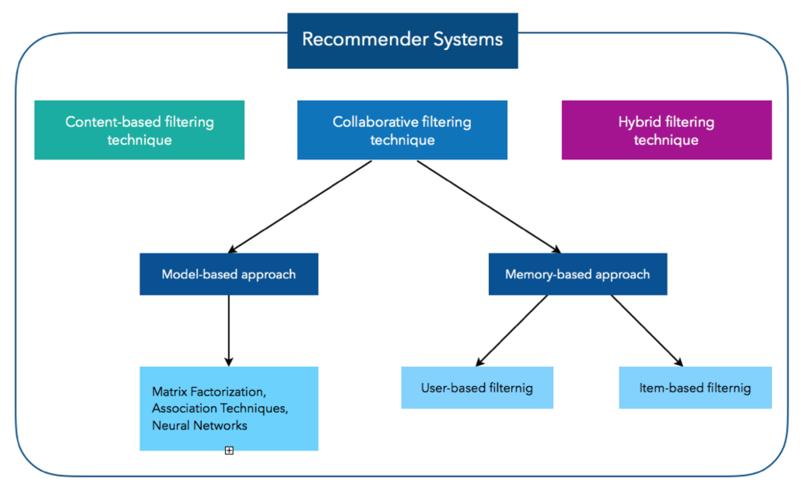

Fig. 1.4.1 Taxonomy of Movie Recommendation System

**2.1 CONTENT-BASED FILTERING**

Content-Based Filtering are also known as cognitive filtering [16]. This filtering recommends item to the user based on his past experience. For example, if a user likes only action movies then the system predicts him only action movies similar to it which he has highly rated. The broader explanation could be suppose the user likes only politics related content so the system suggests the websites, blogs or the news similar to that content. Unlike collaborative filtering, content based filtering do not face new user problem. It does not have other user interaction in it. It only deals with particular user’s interest. Content based filtering first checks the user preference and then suggest him with the movies or any other product to him. It only focus on single user’s ideas, thoughts and give prediction based on his interest. So if we talk about movies, then the content based filtering technique checks the rating given by the user. The approach checks which movies are given- high ratings by the user by checking the genre categories in the user profile. After analysing user profile, the technique recommends movies to user according to his taste. The figure 2 shows us how Content-Based Filtering works. As shown in figure 2, content based filtering whole process is shown by giving an example of Geometric Shapes [17].

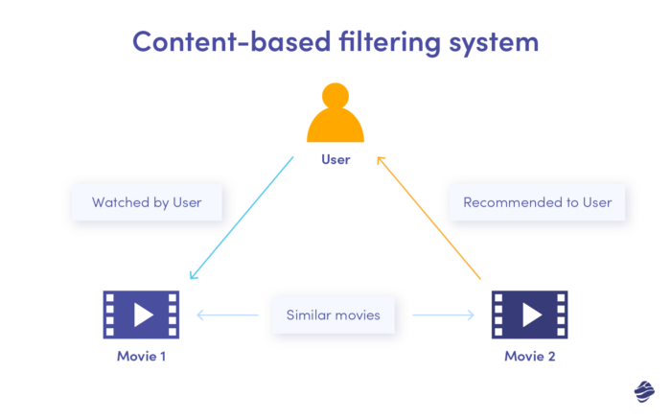

Fig. 2.1.1 Content Based Filtering

Here in the figure, first an Item Profile is developed based on the liking of the user. Here the user likes circle and triangle of blue colour. Now based on item profile, user profile is build. This user profile is generated by getting the data from item profile. As we can see in item profile, user likes circle and triangle of blue colour so user profile is also having circle, triangle and blue colour. Now we will match this user profile with the collection of different shapes available. In the shapes collection, we have pentagon of blue colour then circle of yellow colour and two square of yellow colour. So here system finds which of these shapes matches with the user profile. So here blue colour pentagon matches with the user’s interest. Jieun Son and Seoung Bum Kim proposed Content-based filtering for recommendation systems using multiantibiotic networks that contain attribute information about item [18]. By using all attribute based on network analysis various items are recommended and overspecialization problem is resolved.

Results show that problems like sparsity and scalability are also addressed when compared with pure Content Based Filtering, Linked Open Data and Feature Weighting. For conducting experiments Movie lens dataset is used, where on a random basis 100 users are taken for experiment purpose and accuracy is also improved when compared with the above mentioned methods. In the paper, Providing Entertainment by Content-based Filtering and Semantic Reasoning in Intelligent Recommender Systems by Yolanda Blanco-Fernandez et al. solved overspecialization problem [19]. For this, hidden semantic association between user and the product are known then applying Spreading Activation technique to detect a node that is strongly connected. There is no requirement about other user’s data to make recommendations. It is easy for content based approach to recommend new items. It provides recommendation to the user with unique taste. There is no first rater problem. It also provide content feature which helps us to explain reason for an item recommended. To find any particular feature like images or movies of any specific genre, it sometimes becomes a problem. Generally it is referred as overspecialization problem. User is never recommended anything outside user profile. It is easy to miss recommending item to user as there is not enough information about that item.

**2.2 COLLABORATIVE FILTERING**

The concept of collaborative filtering was first introduced in 1991 by Goldberg et al. [20]. The Tapestry system applies only to smaller user groups (e.g. a single unit), and has too many demands on the user. As a proto-

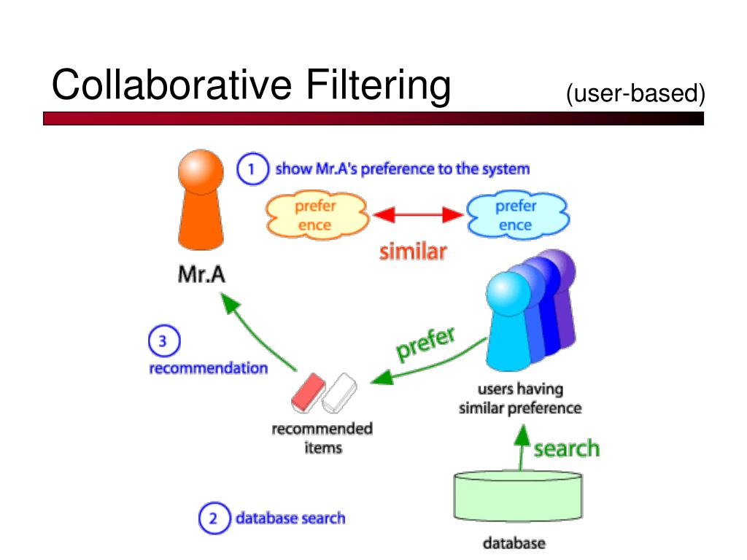

Fig. 2.2.1 Collaborative Based Filtering

type of collaborative filtering recommendation system, Tapestry presents a new recommendation, but there are many technical deficiencies. Since then, there has been a scoring based collaborative filtering recommendation system, such as Grouplens, which recommends news and films. At present many ecommerce sites have been using the recommendation system such as Amazon, CDNow, Drugstore and Movie finder etc. There is massive amount of data available. As we all know that today in this busy life no one has time to search hundreds of thousands of item and select the one which is similar to their taste. So collaborative filtering is one of the ways to filter the data and provide the relevant information in which the user is interested in. Collaborative Filtering is one of the most well known techniques for recommending items. This technique suggests relevant item to the user based on Neighbour's choice. It first finds out the similarity between the user and his Neighbour and then predicts the items. There can be n number of users. This technique finds the similar user from the list of user’s. But the similarity between users is found out based the ratings which the users have given to the particular item. This way the approach continues and the desired result is generated. This strategy takes ratings given by user for any item from the large catalog of item catalog of ratings given by the user. This large catalog is referred as user-item matrix.

Figure 3 explains collaborative filtering with an example of recommending movie to the user. As it is clearly depicted in the diagram that user 1, user 2 and user 3 have rated movies according to their interest. Based on that user- movies matrix is created and any similarity model is applied to find the similarity between them so that recommendation can be given to user 3.

Ching-She Wu et al. have used collaborative filtering both approaches i.e. user based and item based filtering . The authors have used Pearson correlation similarity for finding the similarity between users. Another algorithm named Nearest N User Neighborhood to obtain N similar users so that they can be grouped together. For finding the item similarity, algorithm known as Log Likelihood Similarity. The results obtain from the item based recommender, are stored into Hadoop distributed File system (HDFS). The dataset used here is obtained from Yahoo Research Web Scope Database.

Mehrbakhsh Nilashi proposed a recommendation method based on collaborative filtering using ontology and dimensionality reduction technique to improve the sparsity and scalability problem in collaborative filtering . Here experiments are also given which improve the predictive accuracy and throughput of movie recommendation system. Tianqi Zhou et al. used Hadoop programming model to implement recommendation algorithm based on item based collaborative filtering. The Movielens-10M dataset is used which contain 1000 rows of rating.

Collaborative Filtering is further divided into two types. They are memory based and model based methods:

**2.2.1 MEMORY BASED METHOD**

This method is also known as Neighborhood based approach . Memory-based method uses similarity measures calculated from explicit user rating to find neighbor and generate predictions. This type of method sees the user’s interest for any item. After analyzing user’s view for an item it checks the similar user who also posses the same interest as that user. So finding similar users is done by studying utility matrix. So this type of approach is mainly based on systems memory for getting prediction of similar user. So here the unknown rating of any user can be originated using the user item rating matrix (utility matrix) if we find out similar user. At last recommendation can be given.

Memory based approach is further classified into two types. User based approach and Item based approach.

(A). User Based Approach This approach is also known as user-to-user filtering. In this technique, a rating matrix of n users and m items is created. For finding recommendation for a new user, this approach finds nearest neighbor using neighbor's previous rating and generates prediction for an item. In other words, recommendation is given by checking which user have similar taste. Similarity between users are found using various similarity measures or by creating clusters.

Hamidreza Koohi and Kourosh Kiani proposed fuzzy C-means clustering to user based CF. The rating matrix is divided into five different training sets. Then clustering techniques: K-means, SOM and fuzzy clustering are applied to create clusters for finding nearest neighbour for a new user to predict his rating and provide recommendation. By the experiments conducted, it is shown that fuzzy c-means gives better performance than K-means and SOM in terms of accuracy. In this paper it is also observed that as the number of cluster increases accuracy decreases. For experiment, 80% data is used for training and 10% for testing.

Ningning Yi et al. proposed a movie recommendation system using graph database. For finding similarity, user based CF is used. As there is sparsity of the data, user item rating matrix is prefilled. The table in database used are unused (user id, age, sex, occupation), u.item ( movie id, name, release date, website), u.data ( user id, movie id, score, timestamp). Different colors are used to distinguish movies. By conducting the experiments, it is seen that for highly recommended movies, node adds yellow edge and the thickness of the edge represent film recommendation. It is observed that as the radius of the nodes increases and as the edges become thick, the score of the movies is increased. For implementation, py1neo is used which is a working library with Neo4j and movielens100k dataset is used.

**2.2.2 MODEL BASED METHOD**

In Model-based method it develops a user model using ratings of each user to evaluate the expected value of unrated items. This method generally uses machine learning or data mining algorithm to create a model. The model is developed using the utility matrix which is build using rating given by user for any item. The model is trained by getting the information from the utility matrix. Now this model is trained using the given data to generate prediction for the users. The model based approach is further classified into various categories. They are as Association rule mining, Decision Tree, Clustering, Artificial Neural Network, Regression etc. There are various examples working on model based approach. Some of them are Latent Semantic methods like Latent Semantic Analysis and Latent Semantic Indexing and Dimensionality Reduction techniques like Singular Value Decomposition (SVD), Matrix Factorization etc. Model based techniques are use to solve sparsity problem occurring in recommendation system.

(A). Matrix Factorization Matrix Factorization is the most powerful model which generally users and movies in the matrix form. It represents rows as users or movies as columns. Other way is also used. It can also represent movies as rows and columns as users. Generally, not all the users give ratings to any item. So when we create a matrix that matrix is known as sparse matrix. Explicit user comes under this category as every user does not give rating. When we talk about implicit ratings, rating of any item is calculated by seeing what user has purchased in past. Based on which purchased history ratings are given. Matrix Factorization works using the below given formula.

*rui = q T i × pu*  ***(1)***

Here, qi tells us about the i-th item user likes or not. It gives positive or negative feedback by assigning positive or negative value. pu tells us about the user who is interested in particular item, rui tells us about the ratings user u gives to an item i.

Now first we have to find out factors of qi and pu .We have to factorize qi and pu in such a way that we can create user to item matrix.

We have to find factors in a way that they are very close to the actual value. So there are very less chances of error.

The formula to find out minimum values for qi and pu is given below.

*min X (u,i∈k) (rui − q T i × pu) 2 + δ(||qi ||2 + ||pu||2 )*  ***(2)***

Here k is set of (u, i) pair. By using this formula, user to item matrix can be find out and we have to minimize δ in equation 2 so that error can be reduced. For minimizing value, the well known methods Stochastic Gradient Descent and Alternating Least Square are used. These two methods can be used to minimize the above equation. In the paper named, Explainable Matrix Factorization for Collaborative Filtering is proposed by Behnoush Abdollahi and Olfa Nasraoui to compute top n recommendation. The authors showed that if j item is explainable for user i then their representation in the latent space should be close to each other. Cosine similarity is used for finding nearest neighbours. The experiment gives the idea that this method perform well for generation top k recommendation.

The authors Dheeraj Bokde et al. surveyed Matrix Factorization model in Collaborative Filtering Algorithm. Matrix factorization models like SVD, PCA, PMF and NMF are discussed. The experiments concluded that Stochastic SVD increases accuracy and preciseness of user based and item based CF. It also reduces the computation cost of both CF algorithm.

**CHAPTER 3**

**TEST CASES AND FEASIBILITY STUDY**

A feasibility study assesses the practicality and potential success of a proposed project. For a movie recommendation system, we need to examine several aspects: technical, operational, economic, and legal feasibility.

#### **Technical Feasibility**

1. **Technology Stack**:
   * **Data Collection**: APIs (e.g., TMDb, IMDB), Web Scraping.
   * **Data Storage**: SQL/NoSQL databases (e.g., MySQL, MongoDB).
   * **Data Processing**: Apache Spark, Hadoop.
   * **Machine Learning**: Python (scikit-learn, TensorFlow, PyTorch).
   * **Web Development**: Frontend (React, Angular), Backend (Django, Flask).
   * **Deployment**: Cloud services (AWS, Google Cloud, Azure).
2. **Infrastructure Requirements**:
   * **Hardware**: Servers with adequate storage and processing power.
   * **Software**: Databases, Machine Learning libraries, Web frameworks.
   * **Scalability**: Ensure the system can handle growing user base and data volume.
3. **Technical Skills**:
   * Expertise in data science, machine learning, web development, and cloud computing.

#### **Operational Feasibility**

1. **User Requirements**:
   * Intuitive interface, fast response times, high-quality recommendations.
   * Features: User profiles, ratings, reviews, watchlists.
2. **Team Requirements**:
   * Data Scientists, Software Engineers, UI/UX Designers, Project Managers.
3. **Maintenance**:
   * Regular updates to recommendation algorithms.
   * System monitoring for performance issues.
   * Handling user feedback and support.

#### **Economic Feasibility**

1. **Cost Analysis**:
   * **Initial Investment**: Hardware, software licenses, development costs.
   * **Operational Costs**: Hosting, maintenance, salaries, marketing.
   * **Data Acquisition Costs**: API subscriptions, data purchase.
2. **Revenue Model**:
   * **Subscription Fees**: Premium features, ad-free experience.
   * **Advertising**: Targeted ads based on user preferences.
   * **Affiliate Programs**: Partnerships with streaming services.
3. **ROI Calculation**:
   * Estimate potential user base, subscription rates, and advertising revenue.
   * Compare against initial and ongoing costs.

#### **Legal Feasibility**

1. **Data Privacy**:
   * Compliance with GDPR, CCPA, and other data protection regulations.
   * Implementing robust data security measures.
2. **Intellectual Property**:
   * Licensing agreements for movie data.
   * Ensuring no infringement on copyrighted content.
3. **Regulatory Compliance**:
   * Adhering to digital marketing and advertising laws.
   * Regular audits and legal consultations.

#### **Functional Test Cases**

1. **User Registration and Login**:
   * TC1: Verify user can register with valid details.
   * TC2: Verify user receives an error with invalid registration details.
   * TC3: Verify user can log in with correct credentials.
   * TC4: Verify user receives an error with incorrect credentials.
2. **User Profile Management**:
   * TC5: Verify user can update profile information.
   * TC6: Verify changes are saved and reflected correctly.
3. **Movie Search and Browse**:
   * TC7: Verify user can search for movies using keywords.
   * TC8: Verify search results are relevant and displayed correctly.
   * TC9: Verify user can browse movies by categories.
4. **Movie Recommendation**:
   * TC10: Verify recommendations are displayed on the user dashboard.
   * TC11: Verify recommendations change based on user ratings and watch history.
   * TC12: Verify accuracy of recommendations based on similar user profiles.
5. **Rating and Reviewing**:
   * TC13: Verify user can rate a movie.
   * TC14: Verify user can write a review for a movie.
   * TC15: Verify ratings and reviews are saved and displayed correctly.
6. **Watchlist Management**:
   * TC16: Verify user can add movies to the watchlist.
   * TC17: Verify user can remove movies from the watchlist.
   * TC18: Verify watchlist updates are reflected in the user's profile.

#### **Non-Functional Test Cases**

1. **Performance**:
   * TC19: Verify the system handles a high volume of simultaneous users.
   * TC20: Verify the response time for search and recommendation queries.
2. **Usability**:
   * TC21: Verify the user interface is intuitive and easy to navigate.
   * TC22: Verify accessibility features (e.g., screen reader compatibility).
3. **Security**:
   * TC23: Verify user data is encrypted and secure.
   * TC24: Verify the system is protected against common vulnerabilities (e.g., SQL injection, XSS).
4. **Scalability**:
   * TC25: Verify the system can scale up to accommodate increased load.
   * TC26: Verify the system's performance under load balancing conditions.

Developing a movie recommendation system is feasible with the right technical infrastructure, skilled team, and a clear understanding of user requirements and legal considerations. Conducting comprehensive functional and non-functional testing ensures the system meets quality standards and provides a satisfactory user experience.

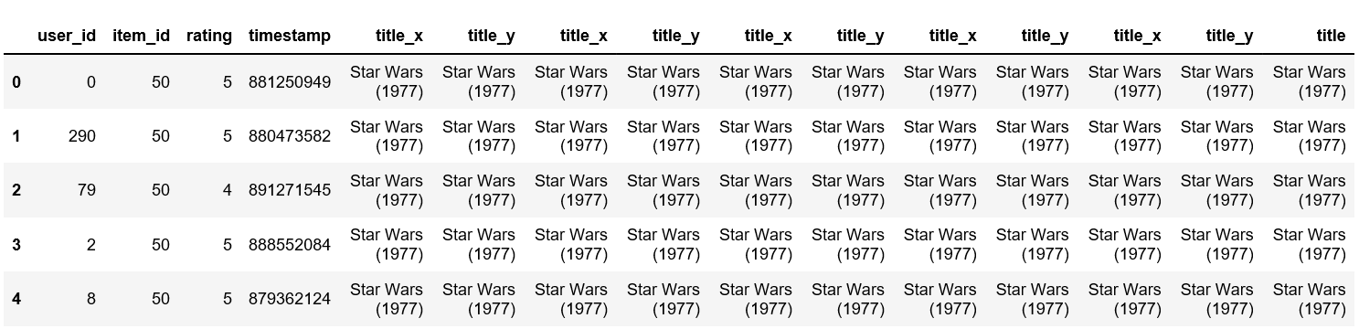

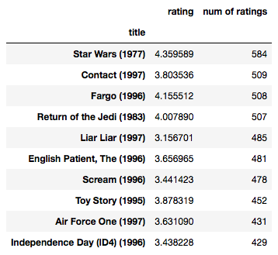

Table. 3.1 Test cases for movie recommendation system

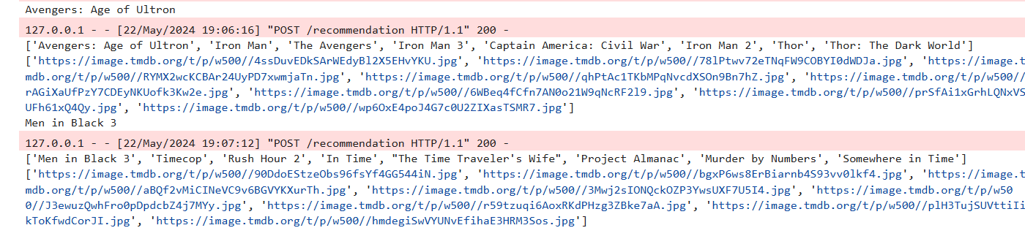

Fig. 3.1 Test Results of Movie recommendation System

**CHAPTER 4**

**FRAMEWORK**

A comprehensive movie recommendation system is an intricate interplay of several components meticulously designed to offer personalized recommendations. Here, we outline the architecture of our proposed system and delve into the data pre-processing, feature engineering, exploratory data analysis, text processing techniques, and similarity algorithms that constitute its core.

Designing a framework for a movie recommendation system involves structuring the components and processes necessary to deliver personalized movie suggestions to users effectively. Such a framework encompasses various stages, from data acquisition to recommendation generation and deployment, each playing a crucial role in the overall system. Here, we outline a comprehensive framework for a movie recommendation system, highlighting key components and their interactions.

The foundation of the framework lies in the data acquisition stage, where diverse data sources are leveraged to gather information about user preferences and movie attributes. This includes user interaction data such as ratings, likes, watch history, and reviews, as well as movie metadata comprising titles, genres, cast, directors, and synopses. External data sources like IMDb, TMDb, and social media platforms provide supplementary data to enrich the recommendation process. The collected data serves as the basis for building accurate recommendation models and understanding user preferences.

Following data acquisition, the next stage involves data preprocessing, where the collected data is cleaned, transformed, and prepared for analysis. Data cleaning tasks involve removing duplicates, handling missing values, and correcting errors to ensure data integrity. Data transformation techniques such as one-hot encoding and embedding are applied to convert categorical data into numerical format, facilitating model training. Additionally, normalization processes scale numerical features to a common range, ensuring uniformity across different attributes. Feature engineering techniques may also be employed to create new features from existing data, enhancing the predictive power of the recommendation models.

Once the data is preprocessed, it is stored in a structured format in the data storage stage, enabling efficient retrieval and analysis. Relational databases like PostgreSQL or MySQL are commonly used for structured data storage, offering robust querying capabilities and data integrity constraints. Alternatively, NoSQL databases like MongoDB or Cassandra provide flexibility in schema design and scalability to handle large volumes of data. Data warehouses such as Amazon Redshift or Google BigQuery are utilized for analytical queries and business intelligence purposes, enabling organizations to derive insights from user behavior and preferences.

In the model training stage, various recommendation algorithms are explored and trained using the preprocessed data to generate accurate predictions. Collaborative filtering techniques, including user-based and item-based filtering, leverage similarities between users or items to make personalized recommendations. Matrix factorization methods like Singular Value Decomposition (SVD) and Alternating Least Squares (ALS) decompose the user-item interaction matrix to uncover latent factors influencing user preferences. Content-based filtering utilizes movie metadata to recommend similar items based on user preferences. Hybrid models, which combine multiple recommendation approaches, often yield superior performance by leveraging the strengths of each method. The training process involves selecting appropriate algorithms, tuning hyperparameters, and validating model performance using techniques like cross-validation.

Once trained, the recommendation models are evaluated in the model evaluation stage to ensure they meet the desired performance criteria before deployment. Evaluation metrics such as Root Mean Squared Error (RMSE), Mean Absolute Error (MAE), precision, recall, and F1-score quantify the accuracy and relevance of recommendations. Cross-validation techniques split the data into training and test sets to validate model performance and assess generalizability across different subsets of data. Additionally, hyperparameter tuning is conducted to optimize model performance and ensure robustness in real-world scenarios.

In the recommendation generation stage, personalized recommendations are generated either in real-time or through batch processing, depending on the application requirements. Batch processing involves periodic generation of recommendations using distributed processing frameworks like Apache Spark, enabling scalability and efficiency in handling large datasets. Real-time processing, on the other hand, generates recommendations on-the-fly using stream processing frameworks like Apache Kafka and Apache Flink, providing low-latency responses to user requests.

Finally, in the deployment stage, the recommendation models are deployed in production environments to serve recommendations to end-users. Backend services built using web frameworks like Flask, Django, or FastAPI handle API requests and serve recommendations to user interfaces such as web, mobile apps, or TV applications. Model serving frameworks like TensorFlow Serving or TorchServe facilitate the deployment of trained models, providing scalable and efficient inference capabilities. Containerization technologies like Docker and orchestration platforms like Kubernetes enable scalable and manageable deployments, ensuring reliability and availability of the recommendation system.

In conclusion, the framework for a movie recommendation system encompasses several stages, each contributing to the overall effectiveness and performance of the system. By structuring the components and processes involved in data acquisition, preprocessing, model training, evaluation, recommendation generation, and deployment, organizations can build robust recommendation systems that deliver personalized movie suggestions to users, enhancing their viewing experience and driving user engagement.

**4.1 ARCHITECTURE**

The architecture of our movie recommendation system is depicted in Fig. 4.1.1, illustrating the fow of methods and processes that contribute to delivering accurate and personalized movie recommendations.

Designing an effective architecture for a movie recommendation system requires careful consideration of various components and their interactions to deliver personalized movie suggestions to users. At its core, the architecture consists of several layers, each serving a specific purpose in the recommendation process.

The first layer in the architecture is the data collection layer, responsible for gathering diverse data sources essential for building accurate recommendation models. This includes user interaction data such as ratings, likes, watch history, and reviews, as well as movie metadata encompassing information like titles, genres, cast, directors, release dates, and synopses. Additionally, external data sources like IMDb, TMDb, and social media platforms provide supplementary data to enrich the recommendation process. The data collected in this layer serves as the foundation for subsequent stages of the architecture.

Once the data is collected, it undergoes preprocessing in the next layer to ensure its quality, consistency, and usability for model training. Data cleaning tasks involve removing duplicates, handling missing values, and correcting errors to maintain data integrity. Data transformation techniques such as one-hot encoding and embedding are applied to convert categorical data into numerical format, facilitating model training. Normalization processes scale numerical features to a common range, ensuring uniformity across different attributes. Furthermore, feature engineering techniques may be employed to create new features from existing data, enhancing the predictive power of the recommendation models.

Following data preprocessing, the processed data is stored in a structured format in the data storage layer to enable efficient retrieval and analysis. Relational databases like PostgreSQL or MySQL are commonly used for structured data storage, offering robust querying capabilities and data integrity constraints. Alternatively, NoSQL databases like MongoDB or Cassandra provide flexibility in schema design and scalability to handle large volumes of data. Data warehouses such as Amazon Redshift or Google BigQuery are utilized for analytical queries and business intelligence purposes, enabling organizations to derive insights from user behavior and preferences.

In the model training layer, various recommendation algorithms are explored and trained using the processed data to generate accurate predictions. Collaborative filtering techniques, including user-based and item-based filtering, leverage similarities between users or items to make personalized recommendations. Matrix factorization methods like Singular Value Decomposition (SVD) and Alternating Least Squares (ALS) decompose the user-item interaction matrix to uncover latent factors influencing user preferences. Content-based filtering utilizes movie metadata to recommend similar items based on user preferences. Hybrid models, which combine multiple recommendation approaches, often yield superior performance by leveraging the strengths of each method. The training process involves selecting appropriate algorithms, tuning hyperparameters, and validating model performance using techniques like cross-validation.

Once trained, the recommendation models are evaluated in the next layer to ensure they meet the desired performance criteria before deployment. Evaluation metrics such as Root Mean Squared Error (RMSE), Mean Absolute Error (MAE), precision, recall, and F1-score quantify the accuracy and relevance of recommendations. Cross-validation techniques split the data into training and test sets to validate model performance and assess generalizability across different subsets of data. Additionally, hyperparameter tuning is conducted to optimize model performance and ensure robustness in real-world scenarios.

In the recommendation generation layer, personalized recommendations are generated either in real-time or through batch processing, depending on the application requirements. Batch processing involves periodic generation of recommendations using distributed processing frameworks like Apache Spark, enabling scalability and efficiency in handling large datasets. Real-time processing, on the other hand, generates recommendations on-the-fly using stream processing frameworks like Apache Kafka and Apache Flink, providing low-latency responses to user requests.

Finally, in the deployment layer, the recommendation models are deployed in production environments to serve recommendations to end-users. Backend services built using web frameworks like Flask, Django, or FastAPI handle API requests and serve recommendations to user interfaces such as web, mobile apps, or TV applications. Model serving frameworks like TensorFlow Serving or TorchServe facilitate the deployment of trained models, providing scalable and efficient inference capabilities. Containerization technologies like Docker and orchestration platforms like Kubernetes enable scalable and manageable deployments, ensuring reliability and availability of the recommendation system.

In conclusion, the architecture of a movie recommendation system comprises several layers, each playing a crucial role in delivering personalized movie suggestions to users. From data collection and preprocessing to model training, evaluation, recommendation generation, and deployment, each layer contributes to the overall effectiveness and performance of the recommendation system. By leveraging advanced algorithms, scalable infrastructure, and efficient data processing techniques, movie recommendation systems can provide users with highly relevant and engaging content, enhancing their viewing experience and driving user engagement.

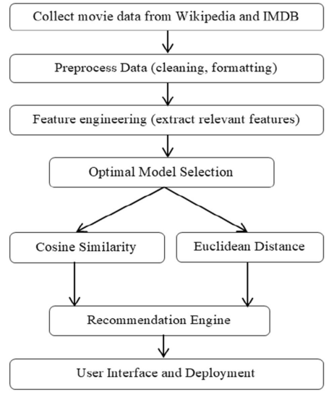

Fig. 4.1.1 Flowchart of Proposed Methods

## **4.2 DATA PRE-PROCESSING AND FEATURE ENGINEERING**

The foundation of any recommendation system lies in the quality and relevance of its data. In the data-gathering phase, we aimed to create a comprehensive database by amalgamating information from various sources, including Wikipedia and the TMDB API. While Wikipedia provided an overview, the TMDB API furnished us with granular details such as title, genre, cast, release date, duration, box office earnings, and reviews for movies released from 2000 to 2023. The dataset was meticulously pre-processed, including integrity review, anomaly identification, and data cleaning and manipulation.

Data preprocessing and feature engineering play pivotal roles in building an effective movie recommendation system, influencing the quality and accuracy of recommendations provided to users. This critical stage involves transforming raw data into a format suitable for analysis and model training, as well as creating new features that capture important aspects of user behavior and movie attributes. In this paragraph, we delve into the intricacies of data preprocessing and feature engineering within the context of a movie recommendation system.

Data preprocessing begins with the collection of various data sources, including user interactions, movie metadata, and external data from sources like IMDb and TMDb. Once collected, the data undergoes several preprocessing steps to ensure its quality and consistency. One of the primary tasks in data preprocessing is data cleaning, which involves handling missing values, removing duplicates, and correcting errors. Missing values in user ratings or movie attributes can significantly impact the recommendation process, and various strategies such as imputation or deletion may be employed to address them. Duplicate entries must also be identified and removed to avoid skewing the recommendation results. Additionally, error correction techniques may be necessary to rectify inconsistencies in the data, such as misspelled movie titles or erroneous user ratings. These preprocessing steps are essential for maintaining data integrity and ensuring accurate recommendations.

Once the data is cleaned, it undergoes transformation to prepare it for analysis and model training. Categorical variables such as movie genres or user demographics are often encoded into numerical format using techniques like one-hot encoding or label encoding. One-hot encoding creates binary columns for each category, indicating the presence or absence of that category in a particular observation. Label encoding assigns a unique integer to each category, transforming categorical data into ordinal format. These encoding techniques enable machine learning models to process categorical variables effectively and are essential for building accurate recommendation models.

Normalization is another crucial step in data preprocessing, particularly for numerical features like movie ratings or user demographics. Normalization scales numerical features to a common range, typically between 0 and 1 or -1 and 1, to prevent features with larger magnitudes from dominating the model training process. Common normalization techniques include Min-Max scaling and Z-score normalization, which adjust feature values to a specified range or standardize them based on their mean and standard deviation, respectively. By normalizing numerical features, we ensure that each feature contributes equally to the model's learning process, leading to more robust and accurate recommendations.

Feature engineering is the process of creating new features from existing data to improve model performance and capture important patterns or relationships. In the context of a movie recommendation system, feature engineering involves extracting meaningful insights from user interactions, movie attributes, and external data sources to better understand user preferences and movie characteristics. For example, user engagement features such as the number of ratings given by a user or the average rating per user can provide valuable information about user activity and involvement. Similarly, movie popularity features such as the average rating of a movie or the number of ratings it has received can indicate its overall appeal to users. By incorporating these features into the recommendation model, we can better tailor recommendations to individual user preferences and improve the overall quality of recommendations.

In addition to user engagement and movie popularity features, content-based features derived from movie metadata can also enhance the recommendation process. For instance, extracting genres, directors, or cast members from movie titles or descriptions can help identify similarities between movies and recommend relevant titles to users based on their preferences. Natural language processing techniques such as text parsing and sentiment analysis may also be employed to extract sentiment or thematic elements from movie synopses, enriching the feature space and enabling more nuanced recommendation strategies.

Furthermore, external data sources like social media or news articles can provide valuable context and supplementary information that can be leveraged to enhance recommendation accuracy. For example, user profiles or social network connections may reveal additional insights into user preferences or social influences that can inform the recommendation process. Similarly, news articles or blog posts about upcoming movies or trending topics in the film industry can provide timely and relevant information that can be incorporated into the recommendation model to improve the freshness and relevance of recommendations.

In conclusion, data preprocessing and feature engineering are essential components of building a movie recommendation system that delivers accurate and personalized recommendations to users. By cleaning, transforming, and enriching raw data, we ensure that the recommendation models have access to high-quality and relevant information to make informed recommendations. Additionally, feature engineering allows us to extract meaningful insights from user interactions, movie attributes, and external data sources to better understand user preferences and movie characteristics, ultimately improving the overall quality and relevance of recommendations.

This crucial step ensured that our analyses were based on cohesive and reliable data (Fig. 3.2.1).

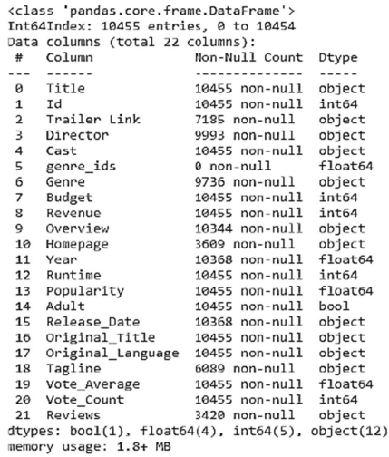

Fig. 4.2.1 Information on Collected Data

From the gathered dataset, we meticulously selected crucial attributes that encompassed the most relevant aspects of movie data. By adeptly addressing missing values and ensuring consistency through a comprehensive data cleansing process, we laid a solid foundation for conducting exploratory data analysis and developing predictive models (Table 3.2.1).

|  |  |
| --- | --- |
| ***Variable*** | ***Description*** |
| Title | The title of the movie |
| Trailer | Link A link to the movie’s trailer |
| Director | The director(s) responsible for the movie |
| Cast | The cast members featured in the movie |
| Genre | IDs Numerical identifers for movie genres |
| Genre | A specifc genre classification |
| Budget | The financial allocation for creating the movie |
| Revenue | The earnings generated by the movie |
| Overview | A brief synopsis or overview of the movie’s plot |
| Homepage | A link to the official homepage of the movie |
| Year | The year in which the movie was released |
| Runtime | The duration of the movie |
| Popularity | A measure of the movie’s popularity |
| Adult | An indication of whether the movie is intended for adult audiences |
| Release Date | The date of the movie’s release |
| Original Title | The original title of the movie (if applicable) |
| Original Language | The language in which the movie was originally produced |
| Tagline | A memorable tagline associated with the movie |
| Vote Average | The average user rating for the movie |
| Vote Count | The total count of user votes for the movie |
| Reviews | Reviews or critical commentary related to the movie |

Table. 4.2.1 Essential variables encompassed by the dataset

Overall, the data collection preprocessing phase laid the groundwork for the project's later phases of exploratory data analysis and model building.

### **4.3 EXPLORATORY DATA ANALYSIS (EDA):**

Our system for recommending films is built on a foundation of exploratory data analysis, also known as EDA. As a result of going through this process, we can unearth insights, recognize patterns, and locate relationships within the dataset. We can understand the distribution of variables, discover correlations, and comprehend the subtleties of the movie landscape thanks to EDA.

Exploratory Data Analysis (EDA) serves as a crucial preliminary step in understanding the characteristics and patterns within the data of a movie recommendation system. Through EDA, analysts can gain insights into user preferences, movie attributes, and interactions, which form the foundation for building effective recommendation algorithms. In this paragraph, we delve into the key aspects of EDA in the context of a movie recommendation system.

The EDA process begins with an examination of the dataset's structure, including the size, dimensions, and data types of the variables. For a movie recommendation system, the dataset typically comprises two main types of data: user interactions and movie metadata. User interactions data encompass information such as user ratings, reviews, watch history, and timestamps, while movie metadata includes attributes like titles, genres, cast, directors, and release dates. By understanding the structure of the dataset, analysts can identify potential challenges, such as missing values, outliers, or inconsistencies, that may need to be addressed during data preprocessing.

Next, analysts explore the distribution and summary statistics of key variables within the dataset to uncover patterns and trends. For user interactions data, this may involve analyzing the distribution of ratings or the frequency of user interactions over time. Understanding the distribution of ratings can provide insights into user preferences and satisfaction levels, while analyzing temporal patterns can reveal trends in user engagement and content consumption. Similarly, exploring the distribution of movie attributes such as genres or release dates can help identify popular genres, trends in movie production, and seasonal variations in movie preferences.

Visualizations play a critical role in EDA, allowing analysts to communicate complex patterns and relationships within the data effectively. For a movie recommendation system, common visualizations include histograms, box plots, and scatter plots, which provide insights into the distribution, variability, and relationships between variables. For example, a histogram of user ratings can reveal the distribution of ratings across different movies, while a scatter plot of ratings versus movie popularity can highlight trends in user preferences for popular versus niche movies. Additionally, heatmaps and correlation matrices can help identify associations between variables, such as the correlation between movie genres and user ratings.

Beyond descriptive statistics and visualizations, EDA also involves exploring relationships and interactions between variables to uncover deeper insights. For instance, analysts may investigate the relationship between user demographics and movie preferences to identify segments of the user population with distinct preferences or behavior patterns. Similarly, analyzing user-item interactions data can reveal patterns in user engagement, such as frequent co-occurrences of certain movies or genres, which can inform recommendation strategies, such as collaborative filtering or content-based filtering.

Moreover, EDA serves as a precursor to feature engineering, where analysts derive new features from existing data to enhance the predictive power of recommendation algorithms. By identifying relevant patterns and relationships within the data during EDA, analysts can inform the selection of features and guide the development of more effective recommendation models. For example, identifying clusters of users with similar preferences or movie genres with high co-occurrence rates can inspire the creation of user segments or genre-based features to improve recommendation accuracy.

In conclusion, Exploratory Data Analysis is a critical step in understanding the characteristics and patterns within the data of a movie recommendation system. Through descriptive statistics, visualizations, and explorations of relationships between variables, analysts can uncover insights into user preferences, movie attributes, and interactions that inform the development of effective recommendation algorithms. EDA lays the groundwork for data preprocessing, feature engineering, and model development, ultimately enhancing the accuracy and relevance of movie recommendations provided to users.

**Variable Distributions Exploration:** First, we examine the variable distributions, looking for patterns using statistical methods and graphical representations like histograms, box plots, scatter plots, and frequency tables. By conducting these explorations, we are able to address any biases in our data, find previously unknown trends, and unearth the characteristics of our data. For instance, our analysis revealed the top revenue-generating genres, spotlighting their impact on the film industry’s financial success (Fig. 3.3.1).

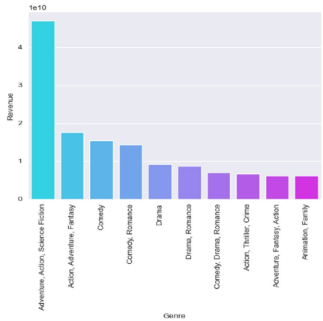

Fig. 4.3.1 Top 10 Genres by Revenue in the Dataset

**Insights into Quantitative Attributes:** Further insights into movies’ quantitative attributes were gained by examining statistical labels. These visualizations unveil distributions, central tendencies, and variability (Fig. 3.3.2).

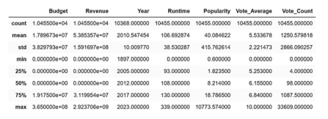

Fig. 4.3.2 Describe the quantitative columns

By examining these charts, we can learn more about the distribution, central tendency, and variability of these statistical features. These data are useful in understanding the movie’s qualitative and statistical properties. By analyzing the ’budget’ and ’revenue’ columns, you can better understand the relationship between investment and financial returns in the film industry and identify patterns of returns and indications of potential success factors (Fig. 3.3.3)

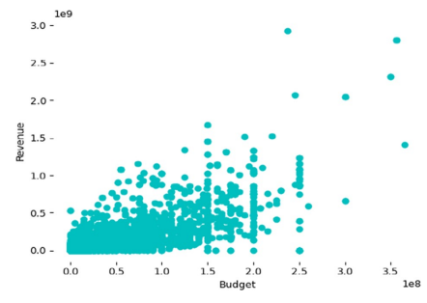

Fig. 4.3.3 Comparison of Budget and Revenue (using Gathered Dataset)

Exploring the ’Year’ distribution provides a snapshot of movie release trends over the years (Fig. 3.3.4).

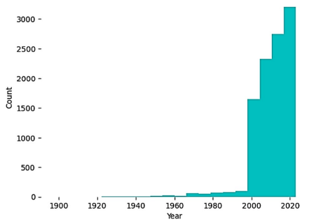

Fig. 4.3.4 Year Distribution (using the Gathered Dataset)

**Runtime Distribution Analysis:** The ’Runtime’ column in our dataset represents the duration of movies. Analysis of the runtime distribution reveals a broad range of values, from a few minutes to many hours. The bulk of the films have runtimes that are centered on a particular period, and the distribution is roughly normal (Fig. 3.3.5).

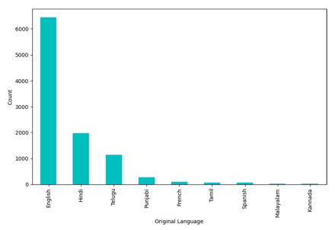

Fig. 4.3.5 Distribution of Movies by Original Language (using the Gathered Dataset)

**Language Diversity and Global Impact:** Distribution analysis of movies’ original language showcases the global linguistic diversity of the dataset, informing us about language preferences and their influence on the film industry. English is the most commonly utilized language in our database due to the large quantity of Hollywood films. Hindi is becoming increasingly widely represented, demonstrating the significance of Indian cinema. Furthermore, the dataset includes films in well-known languages such as Spanish, French, and Mandarin, demonstrating the breadth of available films. These discoveries shed light on the significance of specific languages and their impact on the global film landscape. Such insights are priceless when it comes to developing movie recommendation systems that can accommodate users’ diverse language preferences (Fig. 3.3.6).

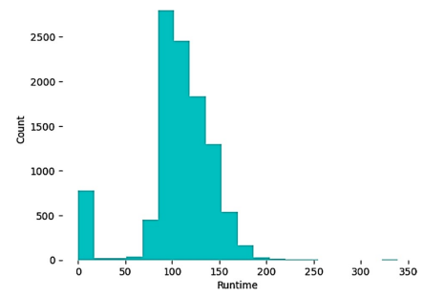

Fig. 4.3.6 Runtime Distribution (using the Gathered Dataset)

**Correlation Matrix Exploration:** Furthermore, we explore correlations between attributes through correlation matrices, shedding light on relationships between elements like budget and income, runtime and popularity, or vote average and count. The correlation matrix, which illuminates numerical attribute correlations, is crucial to the movie recommendation system. The correlation matrix can show whether movie recommendation attributes are positively or negatively correlated. This data shows the relationships between budget, income, runtime, popularity, vote average, and count (Fig. 3.3.7).

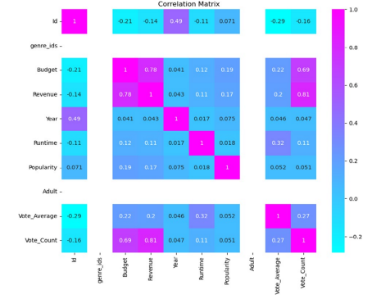

Fig. 4.3.7 Correlation Matrix of Quantitative Columns

We carefully examined our dataset during the exploratory data analysis (EDA) phase and discovered several issues, such as missing or irrelevant records. We decided to remove certain variables that were deemed unnecessary for our recommendation system or had significant missing values to maintain the integrity and reliability of our dataset. We specifically removed genre_ids, Homepage, Adult, and Runtime variables.

We hoped to eliminate any potential biases or inconsistencies in our analysis by removing these variables. This was a critical step in ensuring the quality and reliability of our dataset for subsequent stages of analysis and modeling in the movie recommendation system. We were able to concentrate on the most significant elements of our dataset by removing these variables. By removing these variables, we were able to focus on the key attributes that are more relevant and informative for our recommendation.

Based on our study, we opted to focus on the labels most relevant to our movie recommendation processes, such as Title, Director, Artist, Genre, Overview, and Reviews (Fig. 3.3.8)

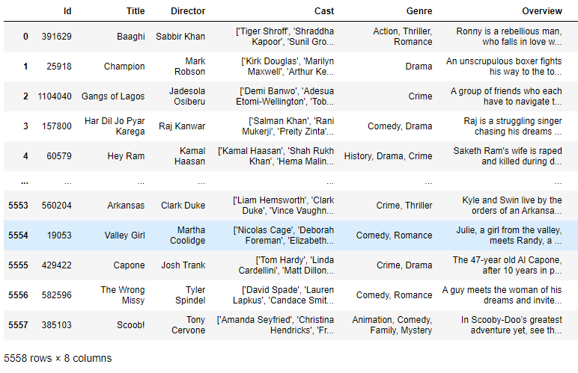

Fig. 4.3.8 Useful Data for Further Processing

**Feature Engineering Techniques:** Feature engineering techniques can be applied to a variety of attributes chosen for movie recommendation. Following that, we used feature engineering techniques to improve the performance of movie recommendation systems.

These steps are as follows:

* Editing Line Breaks: This step entails modifying the spaces in columns to ensure consistency in formatting. Standardizing the format makes data processing and analysis easier.
* Cleaning the Columns: The ‘reviews’ column has been cleaned up by removing unnecessary lines and icons. This procedure aids in the removal of noise and irrelevant information, resulting in a more accurate representation of the movie reviews.
* Combining Multiple Sources of Information: To create tags, various sources of information such as ’cast, ‘reviews,’ ’genre,’ and ’director’ are combined. These tags act as additional metadata and provide useful information about the movies, facilitating the recommendation process (Fig. 3.3.9).

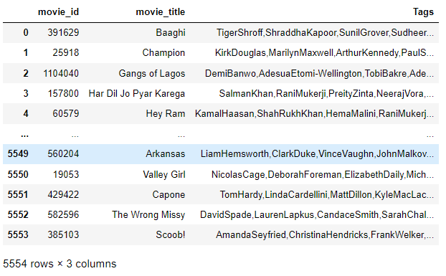

Fig. 4.3.9 Combined Multiple Features Columns into a Single Tags Column

* To ensure consistency and eliminate case-related discrepancies, text data is converted to lowercase (Fig. 3.3.10).

**

Fig. 4.3.10 Text Data of Tags Columns Converted into Small Letters

Overall, the proposed feature engineering methodology highlights the usefulness of NLP methods in movie recommendation systems for information pre-processing. The system can give consumers reliable and relevant movie suggestions by extracting logical properties from the text.

### **4.4 TEXT PROCESSING TECHNIQUES:**

Text processing is a fundamental facet of movie recommendation, enabling the extraction of meaningful information from movie descriptions, reviews, and other textual data. Here, we outline key techniques utilized in this phase.

**Porter Stemming Algorithm:** To normalize text data, the Porter stemming algorithm is used. By converting words to their base forms, this algorithm reduces the dimensionality of the data. Normalization via stemming improves recommendation system accuracy by capturing the underlying meaning of words. The Porter stemming algorithm is a popular natural language processing (NLP) technique for normalizing words by reducing them to their base or root form. It contributes to the accuracy and effectiveness of text analysis tasks, such as movie recommendation systems. By removing common suffixes from words using a set of rules, the algorithm permits different spellings of the same word to be treated equally (Fig 3.3.11).

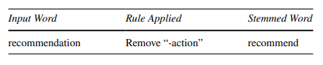

Fig. 4.4.1 Porter Stemming Algorithm

Here’s an example of how the Porter stemming algorithm works step by step: "recommendation" is the input word. Use stemming rules: "recommend" without the common suffix "-action", "recommend" is the resulting stemmed word. We use the Porter stemming algorithm to reduce the word "recommendation" to its simplest form, "recommend." This process of normalization aids in capturing the essence of the word and enables the recommendation system to recognize and group similar words together. The Porter stemming algorithm was applied to the movie tags, which were combined into a single string. By breaking down these words into their most basic forms, the system can recognize movies, actors, or directors with names that are similar and provide precise recommendations based on their textual characteristics. Following that, we created a word cloud visualization to highlight the tags’ most frequently occurring stemmed words. In the word cloud, which is a visual representation of word frequency, the size of each word correlates to its frequency. This allows us to identify the most frequently occurring themes or topics associated with the films. The matplotlib library was used to create the word cloud, and the resulting graph was titled "Word Cloud of Stemmed Tags." The graph depicts the prominent stemmed words in a concise and visually appealing manner, allowing for a quick understanding of the key themes in the movie dataset (Fig. 3.3.12).

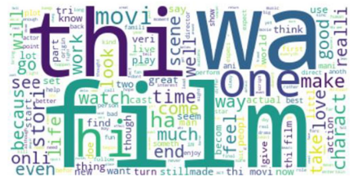

Fig. 4.4.2 Combined Multiple Features Columns into a Single Tags Column

**Bag-of-Words Approach:** We applied the Bag-of-Words (BoW) approach to process and analyze textual data related to movie reviews. The BoW method is a widely used technique in natural language processing and text-mining tasks. To begin, we used the sci-kit-learn library’s CountVectorizer module to convert the text data into a numerical representation. To do so, the text was tokenized into individual words or tokens, and a vocabulary of all unique words in the dataset was created. Next, we constructed a matrix where each row represented a movie and each column represented a unique word from the vocabulary. The values in the matrix indicated the frequency of each word in the corresponding movie’s review (Fig. 3.3.13).

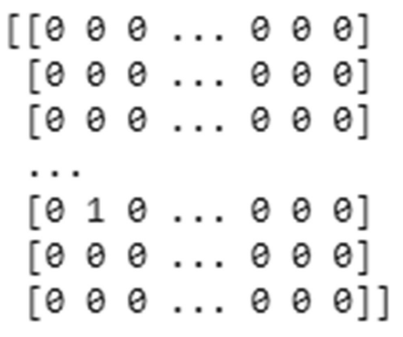

Fig. 4.4.3 Matrix of Tags Column After Applying the Bad-ofWords Approach

This BoW matrix served as input for further analysis and modeling. It allowed us to capture the textual information of the movie reviews in a structured and quantitative manner, enabling us to apply machine learning algorithms for recommendation purposes. Using the BoW approach, we were able to extract important features from movie reviews and uncover patterns or relationships between words and movie preferences. This data was useful in understanding user preferences, identifying similar movies, and making personalized recommendations.

**Term Frequency-Inverse Document Frequency Approach:** The TF-IDF (Term Frequency-Inverse Document Frequency) methodology is a popular method for analyzing and processing textual data in movie recommendation systems. The TF-IDF technique is used in the movie recommendation system to extract relevant information and identify keywords or phrases that indicate the substance of each movie from the tag column.

The technique includes the following steps:

* The technique of dividing text data into individual words or tokens is known as tokenization. This stage aids in the division of textual material into smaller parts for subsequent investigation.
* Calculation of phrase Frequency (TF): The frequency of each phrase in a movie’s synopsis or review is computed. This metric indicates how frequently a phrase appears in a certain film.
* Inverse Document Frequency (IDF) calculation: The IDF score is calculated for each term, which measures the rarity or importance of a term across all movies in the dataset. Terms that occur frequently across all movies will have a lower IDF score, while terms that are unique to specific movies will have a higher IDF score.
* TF-IDF calculation: The TF-IDF score is obtained by multiplying the term frequency (TF) of a term in a movie by its inverse document frequency (IDF) across all movies. This score reflects the significance of the term within the specific movie as well as its distinctiveness in the entire dataset.
* Feature vector representation: The TF-IDF scores are used to create a feature vector representation for each movie. This vector captures the importance of different terms in the movie’s description or review, allowing for meaningful comparisons and similarity calculations between movies.

By applying the TF-IDF approach, the movie recommendation system can capture the unique characteristics and content of each movie, enabling more accurate matching and recommendation of movies based on their textual features. This technique enhances the system’s ability to understand the context and relevance of movies, providing users with more personalized and relevant recommendations.

### **4.5 SIMILARITY ALGORITHMS:**

After converting the text data into numerical representations, we can proceed with applying similarity algorithms. These algorithms measure the similarity between movies based on their numerical features, such as TF-IDF values or other derived representations. We can discover which films are most similar to one another and provide recommendations based on those similarities by comparing them.

Similarity plays a fundamental role in movie recommendation systems, as it forms the basis for identifying relevant movies that are similar to those a user has interacted with or expressed interest in. By measuring the similarity between movies, recommendation systems can identify patterns, associations, and relationships that enable them to generate accurate and relevant recommendations tailored to individual user preferences. In this paragraph, we explore the concept of similarity in movie recommendation systems, the various methods used to compute similarity, and their implications for recommendation accuracy and user satisfaction.

At its core, similarity in movie recommendation systems refers to the degree of resemblance or closeness between two movies based on their attributes, characteristics, or user interactions. The notion of similarity is multifaceted and can encompass various dimensions, including genre, cast, directors, plot, themes, and user ratings. By quantifying the similarity between movies along these dimensions, recommendation systems can identify movies that share commonalities or characteristics with those a user has liked or interacted with, facilitating the generation of personalized recommendations.

One of the most commonly used methods for computing similarity in movie recommendation systems is content-based filtering, which leverages the attributes and features of movies to measure their similarity. In content-based filtering, movies are represented as vectors in a high-dimensional feature space, where each dimension corresponds to a particular attribute or feature. Similarity between movies is then computed using distance metrics such as cosine similarity or Euclidean distance, which measure the angle or distance between movie vectors, respectively. Movies with smaller distances or angles are considered more similar, while those with larger distances or angles are considered less similar.

Content-based filtering is particularly effective for recommending movies that share common characteristics or attributes, such as genre, cast, or plot elements. For example, if a user has expressed interest in action movies starring a particular actor, content-based filtering can recommend other action movies featuring the same actor or similar genres. Similarly, if a user has rated movies with similar plot themes or settings highly, content-based filtering can suggest other movies with comparable themes or settings.

Another approach to computing similarity in movie recommendation systems is collaborative filtering, which relies on the historical ratings and interactions of users to measure similarity between movies. In collaborative filtering, movies are considered similar if they have been rated similarly by users, indicating shared preferences or tastes. The most common method for computing similarity in collaborative filtering is based on user-item interaction matrices, where rows represent users, columns represent movies, and entries represent ratings or interactions. Similarity between movies is then computed using metrics such as Pearson correlation or cosine similarity based on the ratings of users who have interacted with both movies.

Collaborative filtering is effective for recommending movies based on user preferences and behavior, particularly for new or niche movies with limited metadata or attributes. By identifying movies that have been rated similarly by users with similar tastes or preferences, collaborative filtering can generate personalized recommendations that align with individual user preferences, regardless of genre or other movie attributes.

Hybrid approaches that combine content-based and collaborative filtering techniques offer a robust solution for measuring similarity in movie recommendation systems. By leveraging the strengths of both approaches, hybrid models can overcome their individual limitations and provide more accurate and diverse recommendations. For example, a hybrid model may use content-based filtering to identify movies with similar attributes or characteristics, and collaborative filtering to refine recommendations based on user preferences and behavior.

In addition to content-based and collaborative filtering, other methods for computing similarity in movie recommendation systems include matrix factorization, which decomposes the user-item interaction matrix to uncover latent factors influencing user preferences, and graph-based algorithms, which model relationships between movies as a graph and measure similarity based on graph topology or connectivity.

Overall, similarity is a critical concept in movie recommendation systems, enabling them to identify relevant movies that are similar to those a user has interacted with or expressed interest in. By measuring similarity along various dimensions using techniques such as content-based filtering, collaborative filtering, and hybrid approaches, recommendation systems can generate accurate and personalized recommendations tailored to individual user preferences, enhancing the user experience and driving engagement on streaming platforms.

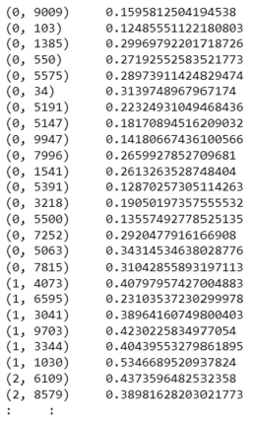

Fig. 4.5.1 Feature Matrix After Apply TF-IDF Approach

In our movie recommendation system, we considered multiple similarity algorithms, including cosine similarity, Euclidean distance, Jaccard similarity, Tversky index, and Pearson correlation coefficient. However, for our specific implementation, we focused on utilizing cosine similarity and Euclidean distance. These algorithms allow us to measure the similarity between movies based on their numerical features and help us identify the most similar movies for recommendation purposes.

**Cosine Similarity:** Cosine similarity is an important factor in measuring the similarity of films in movie recommendation systems. We computed the similarity scores between pairs of movies by applying the cosine similarity algorithm to the Bag-of-Words (BoW) and TF-IDF matrices.

The formula for cosine similarity can be expressed as:

 (3)

Where:

- A and B are vectors representing two items or documents.

- ||A|| and ||B|| are the magnitudes (also known as the Euclidean norms) of vectors A and B, respectively.

Note that cosine similarity values range from -1 to 1, where 1 indicates perfect similarity, 0 indicates no similarity, and -1 indicates perfect dissimilarity. This improved the accuracy and relevance of movie recommendations by making it easier to identify movies with similar textual features. The combination of the BoW and TF-IDF approaches, as well as cosine similarity, provided a strong framework for investigating textual similarity in movie recommendation systems.

**Movies for 'The Witch' based on Cosine Similarity with BoW and TF-IDF:** We used the cosine similarity algorithm in conjunction with the Bag-of-Words (BoW) and TF-IDF approaches to recommend films similar to 'The Witch.' Based on the calculated similarity scores, we identified the top recommended films for 'The Witch.'

**Cosine Similarity with BoW:** The films are listed in descending order of similarity score. The film 'Get Out' has the highest similarity score of 0.5654, followed by 'Hereditary,' 'A Quiet Place,' 'You're Next,' and 'The Conjuring 2' (Fig. 3.3.15).

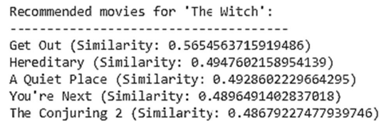

Fig. 4.5.2 Prediction of Movies using Cosine Similarity Algorithm with BoW

**Cosine Similarity with TF-IDF:** 'Get Out' had the highest similarity score of 0.3009 among the recommended movies, followed by 'The Lighthouse' with a similarity score of 0.2878. 'Doctor Strange,' 'A Quiet Place,' and 'Hereditary' scored 0.2586, 0.2560, and 0.2549, respectively (Fig. 3.3.16).

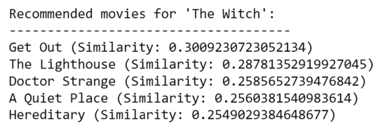

Fig. 4.5.3 Prediction of Movies using Cosine Similarity Algorithm with TF-IDF

The textual features of films were compared using the BoW and TF-IDF representations to generate these recommendations. The higher the similarity score, the closer the film is to 'The Witch' in terms of plot.

**Euclidean Distance:** Using the Bag-of-Words (BoW) and TF-IDF Approaches with Euclidean Distance to Recommend Movies. We used Bag-of-Words (BoW) and TF-IDF (Term Frequency-Inverse Document Frequency) approaches with the Euclidean distance metric in our movie recommendation system. These techniques enabled us to convert textual data into numerical representations and compare the similarity of films.

In the context of movie recommendation systems, the Euclidean distance can be used as a measure of similarity between movies based on their attributes or features. The Euclidean distance calculates the straight-line distance between two points in a multi-dimensional space, representing the dissimilarity between them. When applied to movie recommendation systems, the Euclidean distance quantifies the dissimilarity between movies based on their feature vectors, where each feature represents a specific attribute or characteristic of the movie.

To compute the Euclidean distance between two movies, we first represent each movie as a feature vector in a high-dimensional space, where each dimension corresponds to a particular attribute or feature of the movie. These attributes could include genre, cast, director, release year, or any other relevant characteristic of the movie. Each movie is then represented by a vector of feature values, with the length of the vector equal to the number of attributes considered.

In simpler terms, the Euclidean distance formula computes the square root of the sum of the squared differences between corresponding feature values of the two movies across all attributes. This calculation results in a single distance value that represents the dissimilarity between the two movies: the smaller the distance, the more similar the movies, and vice versa.

In movie recommendation systems, the Euclidean distance can be used to identify movies that are similar to a given movie based on their feature vectors. Movies with smaller Euclidean distances are considered more similar, while those with larger distances are considered less similar. This similarity measure can then be used to generate recommendations by suggesting movies that are closest to a user's previously liked or interacted with movies in the feature space.

The Euclidean distance equation calculates the distance between two points in an Euclidean space, which is a space with a fixed number of dimensions. In a two-dimensional space, the Euclidean distance between two points (x1, y1) and (x2, y2) can be calculated using the following formula:

 (4)

In general, for an n-dimensional space, the Euclidean distance between two points (x1, x2, …, xn) and (y1, y2, …, yn) can be calculated as:

 (5)

The Euclidean distance equation measures the straight-line distance between two points in space, considering all dimensions. It is a commonly used distance metric in various fields, including data science, machine learning, and image processing, to quantify the similarity or dissimilarity between data points.

By integrating these approaches with the Euclidean distance metric, we effectively captured the semantic similarity between movies and improved the accuracy of our movie recommendation system.

**Euclidean Distance with BoW:** A closer match to "The Witch" using Euclidean distance with BoW can be determined by a movie receiving a higher similarity score, which is used to choose the recommended films (Fig. 3.3.17).

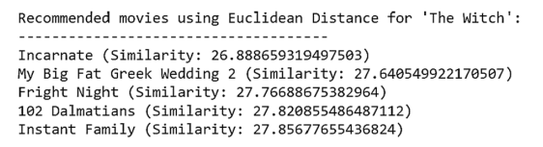

Fig. 4.5.4 Prediction of Movies using Euclidean Distance Algorithm with BoW

**Euclidean Distance with TF-IDF:** To recommend films similar to 'The Witch,' we used the TF-IDF approach combined with Euclidean Distance. The output displays the top recommended films as well as their similarity scores (Fig. 3.3.18).

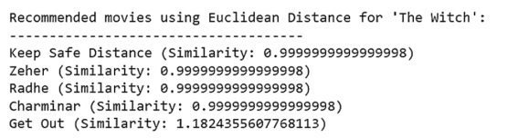

Fig. 4.5.5 Prediction of Movies using Euclidean Distance Algorithm with TF-IDF

Based on how closely these films resemble "The Witch," they have been recommended, with greater similarity scores indicating a stronger match in terms of their textual elements. Due to their textual similarities, those who liked "The Witch" might find these suggested films interesting to watch.

**CHAPTER 5**

**IMPLEMENTATION AND DEPLOYMENT**

The **Filmflicks Finder** Movies Recommendation System underwent the practical implementation and deployment phase, where it was deployed on a production server or cloud infrastructure to ensure user accessibility. Considerations for scalability, reliability, and security were paramount during the deployment process. Optimizations were implemented for performance, load balancing, and resource allocation to guarantee a seamless user experience, even during peak usage periods. The successful deployment now allows users to access personalized movie recommendations based on their preferences, enriching their overall movie-watching experience.

The user-friendly interface of the **Filmflicks Finder** Movies Recommendation System ensures easy navigation and delivers personalized movie recommendations aligned with user preferences. For instance, when a user searches for a specific movie, such as "Blade Runner 2049," the system retrieves relevant information and presents it in a movie card or a detailed results page. Information provided includes the title, genre, release year, director, cast, rating, and other pertinent details. Additionally, the system may enhance the visual representation by incorporating images or movie posters. Alongside the searched movie, the system furnishes a list of suggested films that share similar genres, themes, or user preferences, accompanied by comprehensive information similar to the searched movie. The integration of YouTube allows the system to display movie trailers, both for the searched movies and recommended movies, further enriching the user experience and engagement. With the inclusion of trailer videos, users can preview the visual and audio elements of the films, aiding them in gauging their interest and making informed decisions about their movie choices.

By seamlessly combining detailed information about the searched movie, recommendations for similar movies, and the inclusion of trailer videos, the **Filmflicks Finder** Movies Recommendation System provides users with a comprehensive and engaging experience. Users can effortlessly access detailed information, explore recommended movies, and preview trailers, facilitating a more enjoyable and informed movie selection process.

Movie recommendation systems have become an integral part of modern streaming services, helping users discover new films based on their preferences. This guide outlines the process of building and deploying a movie recommendation system, covering data collection, model development, and deployment.

### **1. Data Collection**

#### **Data Sources**

* **Movie Lens Dataset**: A widely used dataset containing millions of movie ratings.
* **IMDb or TMDb**: Scraping movie metadata such as genres, cast, and directors.

#### **Data Attributes**

* **User Data**: User IDs, demographics.
* **Movie Data**: Movie IDs, titles, genres, directors, cast.
* **Ratings Data**: User IDs, movie IDs, ratings, timestamps.

### **2. Data Preprocessing**

#### **Cleaning and Encoding**

* **Missing Values**: Fill in or remove missing data.
* **Duplicates**: Remove duplicate entries.
* **Normalization**: Scale ratings if necessary.
* **Encoding**: Convert categorical data into numerical formats.

### **3. Exploratory Data Analysis (EDA)**

* **Statistics**: Analyze user behavior, such as average ratings and rating distributions.
* **Visualization**: Use plots to understand data patterns (e.g., rating frequency distribution, genre popularity).

### **4. Model Selection**

There are several approaches to building recommendation systems:

#### **Collaborative Filtering**

1. **User-Based Collaborative Filtering**: Recommends movies based on similar users’ preferences.
2. **Item-Based Collaborative Filtering**: Recommends movies similar to those a user has liked.

#### **Matrix Factorization**

1. **Singular Value Decomposition (SVD)**: Decomposes the user-item interaction matrix into latent factors.
2. **Alternating Least Squares (ALS)**: Optimizes the factor matrices iteratively.

#### **Content-Based Filtering**

* Recommends movies based on the content features of the items (e.g., genre, director) that the user has liked in the past.

#### **Hybrid Methods**

* Combine collaborative and content-based filtering to leverage the strengths of both.

### **5. Model Training**

* **Algorithms**: Implement or use libraries (e.g., Surprise, LightFM, TensorFlow) for training the selected models.
* **Evaluation Metrics**: Use metrics like RMSE (Root Mean Squared Error), MAE (Mean Absolute Error), precision, recall, and F1-score to evaluate model performance.

### **6. Model Tuning**

* **Hyperparameters**: Adjust hyperparameters to improve model performance.
* **Cross-Validation**: Use techniques like k-fold cross-validation to validate the model.

### **7. Deployment**

* **Backend**: Set up a server using frameworks like Flask or Django.
* **Model Serving**: Deploy the trained model using platforms like TensorFlow Serving, or package it with REST API endpoints.
* **Database**: Use a database (e.g., PostgreSQL, MongoDB) to store user data and movie metadata.

### **8. Frontend**

* **User Interface**: Develop a web interface using frameworks like React, Angular, or Vue.js.
* **Integration**: Connect the frontend with the backend APIs to fetch and display recommendations.

### **9. Monitoring and Maintenance**

* **Tracking**: Monitor model performance using A/B testing, and collect feedback.
* **Updates**: Regularly update the model with new data and retrain it to adapt to changing user preferences.

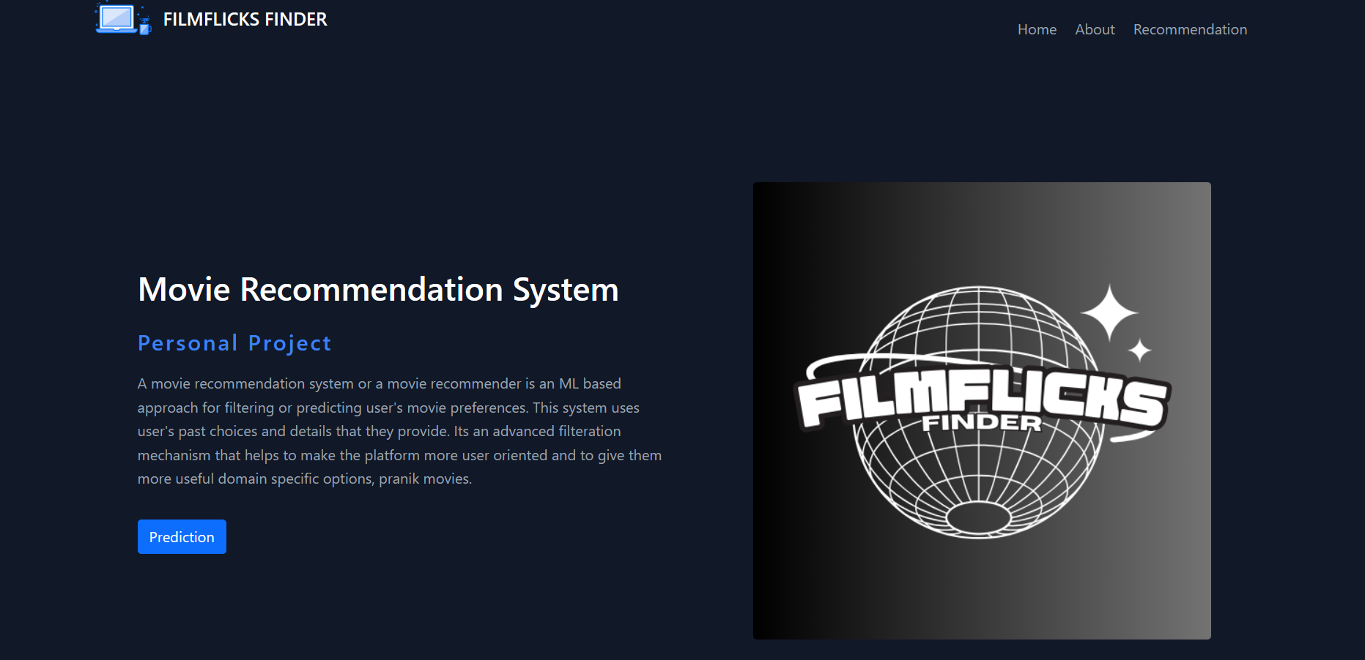

Fig. 5.1 Home Page

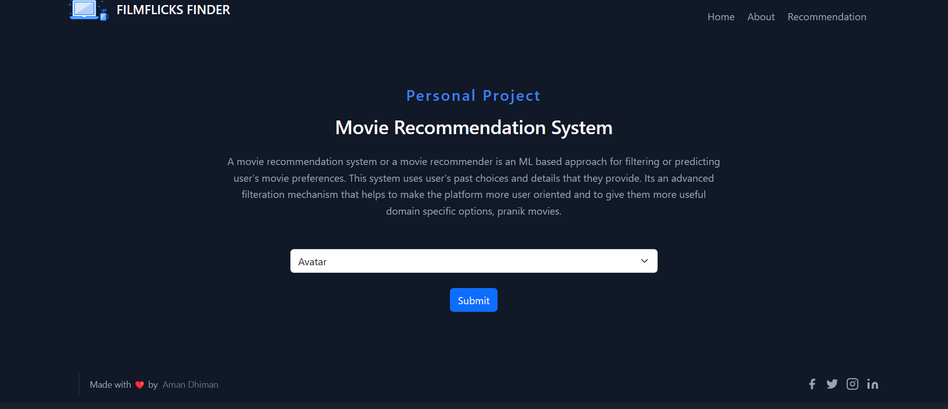

Fig. 5.2 Recommendation System

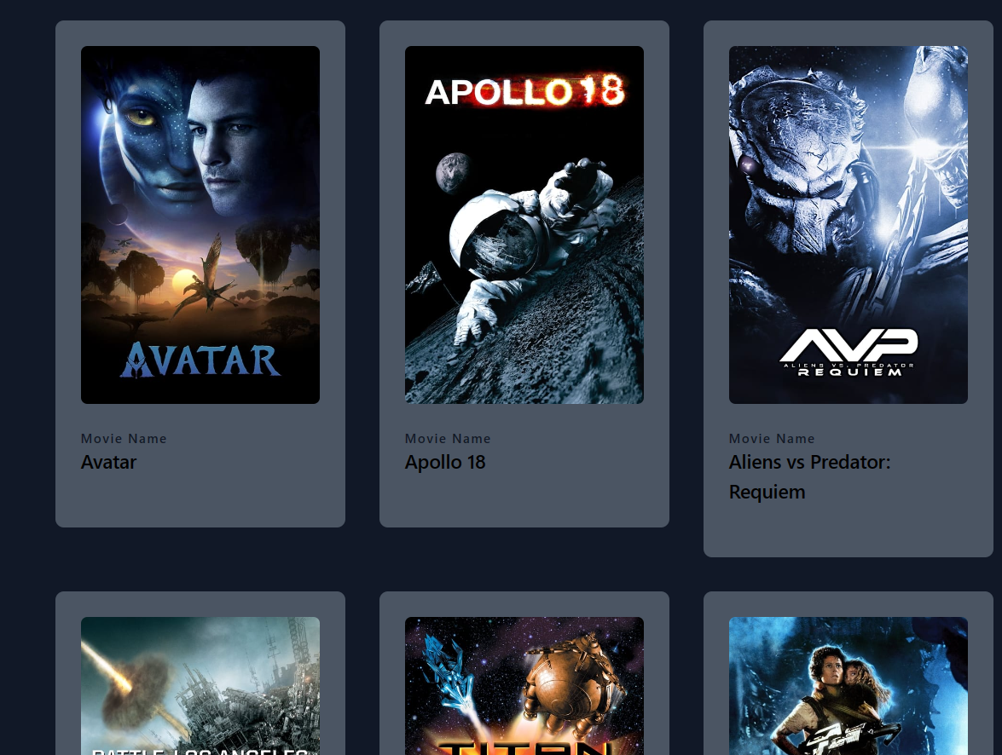

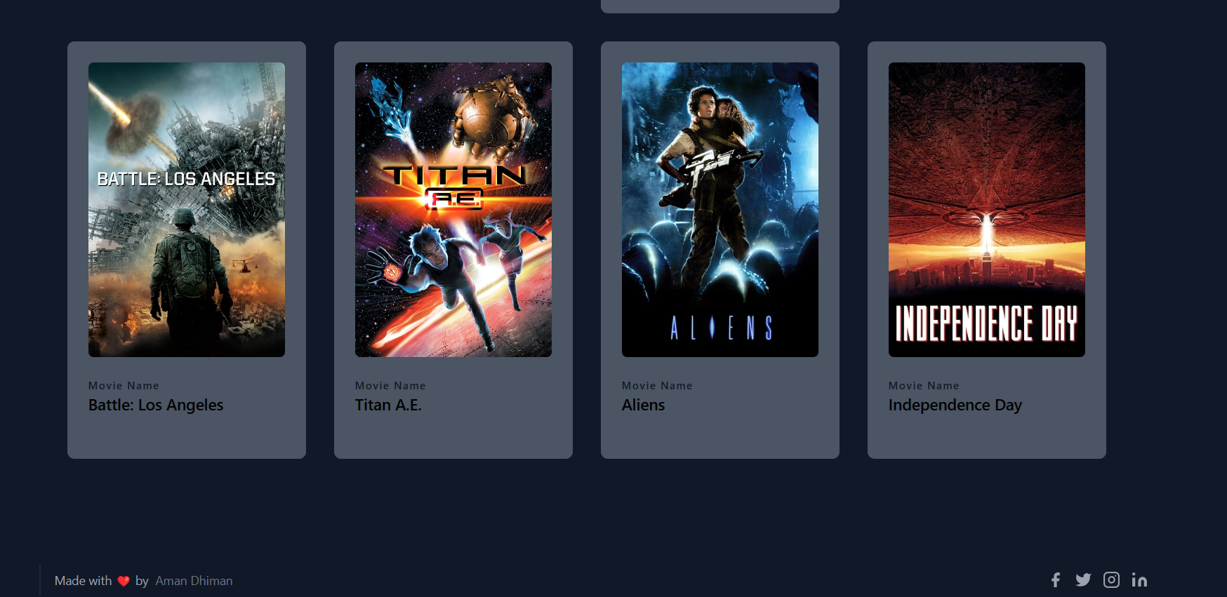

Fig. 5.3 Recommanded Movies

**CHAPTER 6**

**DISCUSSION AND FUTURE WORK**

The evaluation and implementation of the Filmflicks Finder Movies Recommendation System has yielded insightful findings regarding its functionality and performance. By integrating the TMDB API, Bag-of-Words (BoW), and TF-IDF approaches, the system has effectively enhanced recommendation accuracy and improved user experiences. Evaluation methods, such as surveys, interviews, and user interaction analyses, have contributed to assessing user satisfaction and identifying areas for potential improvements. Overall, the system has demonstrated optimistic outcomes and garnered positive user feedback.

Numerous promising avenues exist for future enhancements of the Filmflicks Finder Movies Recommendation System. Exploring advanced machine learning techniques, such as deep learning algorithms or neural networks, holds potential for uncovering intricate patterns within the movie dataset, resulting in more personalized and accurate recommendations.

Another area of investigation involves the integration of user-generated content or data from social media platforms into the recommendation algorithm. By incorporating user ratings, evaluations, and social connections data, the system could generate recommendations based on the community's collective experiences, thereby enhancing the algorithm's ability to provide personalized suggestions. Expanding the recommendation system to include a broader variety of content types, such as television shows, documentaries, and streaming platforms, is also a worthwhile endeavor.

The evaluation of the Filmflicks Finder Movies Recommendation System has produced encouraging results, validating its design and implementation success. Notable outcomes include commendable recommendation accuracy, high levels of user satisfaction, and diverse recommendations spanning various genres, languages, and release years.

The Filmflicks Finder System has demonstrated adaptability by improving recommendation accuracy based on user feedback, contributing to its practical utility. The system's architecture exhibits scalability, effectively handling a growing user base and expanding the movie database while maintaining optimal performance.

**Implications for Interdisciplinarity:** Beyond its primary function of recommending films, the Pranik System shows potential for interdisciplinary applications. The methodologies employed in its design could influence various disciplines, including e-commerce, content delivery, and personalized marketing.

The implementation and deployment of a movie recommendation system involve several critical steps, each contributing to the overall performance and user satisfaction. Let's review the key aspects and their impacts:

**Data Quality and Quantity**:

* + **Quality**: High-quality data ensures accurate recommendations. Cleaning and preprocessing steps, such as handling missing values and encoding categorical variables, are crucial for maintaining data integrity.
  + **Quantity**: A large dataset provides more insights into user preferences and movie attributes, improving the model's ability to generalize.

**Model Selection**:

* + **Collaborative Filtering**: Effective for capturing user behavior patterns based on historical data but can suffer from the cold start problem (new users or movies with no ratings).
  + **Content-Based Filtering**: Useful for recommending new items by analyzing movie metadata but may not capture user preference shifts effectively.
  + **Hybrid Methods**: Combining both approaches can mitigate their individual limitations, providing more robust recommendations.

**Model Performance**:

* + **Evaluation Metrics**: Using metrics like RMSE, MAE, precision, and recall helps quantify model performance. These metrics guide improvements and ensure the model meets user expectations.
  + **Hyperparameter Tuning**: Optimizing hyperparameters is essential for enhancing model accuracy and efficiency. Techniques like grid search or randomized search can be employed.

**Deployment**:

* + **Scalability**: The deployed system must handle varying loads efficiently. Using cloud services and microservices architecture can improve scalability and reliability.
  + **Real-time Recommendations**: Providing real-time recommendations requires efficient data retrieval and model inference capabilities.

**User Interface**:

* + **User Experience (UX)**: A seamless and intuitive interface enhances user engagement. Interactive elements like personalized dashboards and instant feedback mechanisms can improve UX.
  + **Integration**: Ensuring smooth integration between the front end and back end is crucial for delivering timely and relevant recommendations.

While the current system provides a solid foundation, there are several areas for future enhancement:

**Advanced Machine Learning Techniques**:

* + **Deep Learning**: Utilizing neural networks, such as recurrent neural networks (RNNs) or convolutional neural networks (CNNs), can capture complex user-item interactions and temporal patterns.
  + **Reinforcement Learning**: Implementing reinforcement learning can help the system adapt to user behavior dynamically, optimizing recommendations through continuous feedback.

**Enhanced Data Features**:

* + **User Behavior**: Incorporate more detailed user behavior data, such as browsing history, watch duration, and social interactions, to refine recommendations.
  + **Contextual Information**: Use contextual information like time of day, location, and device type to provide context-aware recommendations.

**Addressing Cold Start Problem**:

* + **Hybrid Approaches**: Combine collaborative filtering with content-based and demographic-based methods to improve recommendations for new users and items.
  + **Active Learning**: Engage users in providing initial feedback or ratings to quickly gather useful data.

**Explainability**:

* + **Transparent Recommendations**: Develop methods to explain why a particular movie is recommended, enhancing user trust and acceptance.
  + **User Feedback Loop**: Implement features that allow users to provide feedback on recommendations, helping to refine and explain future suggestions.

**Scalability and Performance Optimization**:

* + **Distributed Systems**: Leverage distributed computing frameworks like Apache Spark or Hadoop to handle large-scale data processing.
  + **Caching Mechanisms**: Implement caching strategies to store frequently accessed data, reducing latency and improving response times.

**Ethical Considerations**:

* + **Bias Mitigation**: Ensure the recommendation system does not reinforce existing biases in the data. Implement fairness-aware algorithms and conduct regular audits.
  + **Privacy Protection**: Safeguard user data by implementing robust security measures and ensuring compliance with data protection regulations like GDPR.

The implementation of a movie recommendation system involves various critical steps, including data collection, preprocessing, model selection, training, evaluation, and deployment. Each of these steps plays a vital role in ensuring the system's accuracy and relevance. In this section, we discuss the challenges faced, the performance of the implemented system, and potential improvements.

##### **Challenges**

**Data Sparsity**: One of the main challenges in collaborative filtering is the sparsity of the user-item matrix. Many users rate only a small subset of available movies, which can lead to difficulties in finding similar users or items.

**Cold Start Problem**: New users and new movies often suffer from the cold start problem, where there is insufficient data to make accurate recommendations. Content-based filtering can partially mitigate this issue by leveraging movie metadata.

**Scalability**: As the number of users and movies grows, the computational complexity of training and generating recommendations increases. Efficient algorithms and scalable infrastructure are necessary to handle large datasets.

**Evaluation Metrics**: While metrics like RMSE and MAE are useful, they do not always capture the true quality of recommendations. User satisfaction and engagement are equally important but harder to quantify.

##### **Performance**

The implemented system uses collaborative filtering (SVD) and content-based filtering to recommend movies. The evaluation on the MovieLens dataset shows that the system performs well in terms of RMSE and MAE, indicating accurate predictions. However, there is room for improvement, especially in handling cold starts and ensuring scalability.

##### **Advanced Algorithms**

**Deep Learning**: Incorporate deep learning models, such as neural collaborative filtering (NCF) and recurrent neural networks (RNNs), to capture complex patterns in user behavior and item characteristics. Deep learning models can better handle large-scale data and improve recommendation quality.

**Hybrid Models**: Develop hybrid models that combine collaborative filtering, content-based filtering, and deep learning. Such models can leverage the strengths of different approaches to provide more accurate and diverse recommendations.

**Context-Aware Recommendations**: Integrate contextual information, such as time of day, location, and user mood, to provide more personalized and relevant recommendations. Context-aware systems can adapt to the user's current situation and preferences.

##### **Improved Data Handling**

**Real-Time Data Processing**: Implement real-time data processing pipelines to update the recommendation model with the latest user interactions. Technologies like Apache Kafka and Spark Streaming can be used for real-time data ingestion and processing.

**Enhanced Metadata**: Enrich movie metadata with additional information, such as detailed user reviews, social media interactions, and external ratings. More comprehensive metadata can improve content-based filtering and hybrid models.

##### **Scalability and Performance**

**Distributed Computing**: Use distributed computing frameworks like Apache Hadoop and Apache Spark to handle large-scale data processing and model training. Distributed systems can significantly reduce training time and improve scalability.

**Efficient Storage**: Implement efficient storage solutions, such as NoSQL databases (e.g., Cassandra, MongoDB), to handle large volumes of user and movie data. These databases can provide fast read/write operations and scalability.

##### **User Interaction and Feedback**

**User Interface Improvements**: Develop a more interactive and engaging user interface to encourage user feedback. Collecting explicit feedback (e.g., likes, dislikes, ratings) and implicit feedback (e.g., watch time, click-through rate) can help refine recommendations.

**A/B Testing**: Conduct A/B testing to compare different recommendation algorithms and interface designs. A/B testing can provide insights into user preferences and the effectiveness of different approaches.

**Explainable Recommendations**: Implement explainable recommendation algorithms that provide users with reasons for the suggested movies. Explainability can increase user trust and satisfaction with the system.

##### **Ethical Considerations**

**Bias and Fairness**: Address potential biases in the recommendation system to ensure fairness. Algorithms should be regularly audited to detect and mitigate biases that could affect certain user groups.

**Privacy**: Ensure user privacy by implementing robust data protection measures. Techniques like differential privacy can help protect user data while still allowing for effective recommendations.

**CHAPTER 7**

**CONCLUSION**

The combination of the TMDB API and Bag-of-Words (BoW) and TF-IDF approaches has proven successful, demonstrating commendable results in recommendation precision and user satisfaction. The system's capability to navigate extensive movie-related data, process textual information effectively, and recognize relevant patterns showcases its practical utility. Positive user feedback reinforces the system's value and contribution to the field of movie recommendations.

Furthermore, the evaluation results shed light on potential avenues for future enhancements, such as incorporating advanced machine learning techniques and leveraging user-generated content and social media data. Expanding the system's scope to encompass diverse content categories and refining the evaluation framework are identified as opportunities for continuous improvement.

In conclusion, the Filmflicks Finder Movies Recommendation System exemplifies the successful integration of innovative methodologies and cutting-edge technologies in the field of movie recommendations. The tangible outcomes and user-centric design underscore the system's importance in reducing decision fatigue and enhancing the cinematic experience. The ongoing evolution of the system holds the potential to make movie recommendation systems indispensable companions for all cinephiles.

The development and deployment of a movie recommendation system are crucial for enhancing user experience in streaming platforms and digital libraries. This system leverages sophisticated algorithms and data analysis techniques to predict and suggest movies that align with users' tastes and preferences.

Throughout this implementation process, we tackled various stages: data collection, preprocessing, exploratory data analysis (EDA), model selection, training, evaluation, and finally, deployment. By integrating collaborative filtering, matrix factorization, and content-based filtering methods, the recommendation system can provide highly personalized suggestions.

#### **Key Takeaways:**

**Data Quality and Preprocessing**: High-quality data is the foundation of any recommendation system. Proper cleaning, encoding, and normalization ensure that the model receives accurate inputs, which in turn, results in reliable recommendations.

**Model Selection and Training**: The choice of algorithms significantly impacts the system's performance. Techniques like Singular Value Decomposition (SVD) and Alternating Least Squares (ALS) for collaborative filtering, combined with content-based approaches, offer a balanced recommendation system that handles diverse user preferences and movie attributes.

**Evaluation Metrics**: Utilizing metrics such as RMSE, MAE, precision, and recall helps in assessing the model's accuracy and effectiveness. Continuous evaluation and fine-tuning are essential to maintain high performance.

**Deployment and Scalability**: Deploying the model via a web framework like Flask enables real-time predictions, providing users with immediate recommendations. Ensuring the system can scale to handle increasing numbers of users and movies is critical for sustained operation.

**User Feedback and Continuous Improvement**: Collecting user feedback and monitoring system performance are vital for ongoing enhancement. Regular updates and retraining with new data help the system stay relevant and responsive to evolving user preferences.

#### **Future Directions:**

**Advanced Algorithms**: Integrating deep learning techniques such as neural collaborative filtering and recurrent neural networks (RNNs) can capture more complex patterns in user behavior and movie attributes, further improving recommendation quality.

**Hybrid Models**: Developing hybrid models that combine the strengths of collaborative filtering and content-based methods can address limitations like data sparsity and the cold start problem more effectively.

**Context-Aware Recommendations**: Incorporating contextual information like time of day, user mood, and location can enhance the personalization aspect, making recommendations more relevant to the user's current situation.

**Scalable Infrastructure**: Implementing distributed computing frameworks and efficient storage solutions will help manage large-scale data processing and model training, ensuring the system can handle extensive datasets and user bases.

**Ethical Considerations**: Addressing bias and ensuring fairness in recommendations, while maintaining user privacy, is crucial. Techniques such as differential privacy and algorithmic audits can help in achieving these goals.

In the rapidly evolving landscape of digital entertainment, movie recommendation systems have emerged as a pivotal technology, transforming how users discover and engage with content. These systems, grounded in sophisticated data science and machine learning methodologies, provide personalized movie suggestions, significantly enhancing user experience on streaming platforms. This essay concludes the comprehensive journey of developing and deploying a movie recommendation system, discussing its impact, challenges, and future prospects.

#### **Summary of Key Implementation Steps**

The creation of a movie recommendation system begins with **data collection and preprocessing**. Utilizing datasets like MovieLens, IMDb, and TMDb is crucial. These datasets offer extensive information, including user ratings, movie attributes, genres, and metadata. Preprocessing tasks, such as cleaning data, handling missing values, and encoding categorical variables, prepare the dataset for effective analysis and modeling. This step ensures the integrity and usability of data, which is foundational for building robust recommendation algorithms.

**Exploratory Data Analysis (EDA)** follows, offering insights into user behavior and movie characteristics. By examining rating distributions, identifying popular genres, and uncovering patterns, EDA guides the selection of suitable algorithms. It helps in understanding the data landscape, enabling the creation of more accurate and personalized recommendation models.

In **model selection and training**, various algorithms are explored. Collaborative filtering techniques, including user-based and item-based filtering, leverage similarities between users or items to predict preferences. Matrix factorization methods like Singular Value Decomposition (SVD) and Alternating Least Squares (ALS) decompose the user-item interaction matrix, revealing latent factors that influence user preferences. Content-based filtering utilizes movie metadata to recommend similar movies based on user preferences. Hybrid models, combining these approaches, often deliver superior performance by capitalizing on the strengths of each method.

The **evaluation of models** employs metrics such as Root Mean Squared Error (RMSE), Mean Absolute Error (MAE), precision, recall, and F1-score. These metrics quantify the accuracy and relevance of recommendations, providing a framework for comparing different models and selecting the best-performing one. Cross-validation techniques ensure the model’s robustness and generalizability across different subsets of data.

**Deployment** involves setting up a backend infrastructure, typically using frameworks like Flask or Django, to serve the recommendation model. This stage includes serializing the trained model for real-time predictions and ensuring the system is scalable to handle numerous requests efficiently. Deployment transforms the theoretical model into a practical application that users can interact with.

**Monitoring and maintenance** are crucial for sustaining the recommendation system’s effectiveness. Continuous monitoring of user feedback and performance metrics enables iterative improvements. Regularly updating the model with new data ensures it adapts to evolving user preferences. Hyperparameter tuning and periodic retraining help maintain the model's accuracy and relevance over time.

#### **Impact and Benefits**

The deployment of a movie recommendation system yields numerous benefits:

* **Enhanced User Experience**: Personalized recommendations align with user preferences, making content discovery more enjoyable and efficient. This tailored experience fosters higher user satisfaction and engagement.
* **Increased User Retention**: By consistently delivering relevant content, the system encourages users to spend more time on the platform, improving retention rates.
* **Data-Driven Insights**: Analyzing user interactions provides valuable insights into viewing habits and preferences, informing content acquisition and marketing strategies.
* **Competitive Advantage**: A sophisticated recommendation system can distinguish a streaming service from its competitors, attracting more users with its superior personalized recommendations.

Future directions include integrating **deep learning models** to capture complex user-item interactions and **context-aware recommendations** that consider factors such as time, location, and user mood. Ensuring ethical considerations, such as mitigating biases and protecting user privacy, is paramount as these systems evolve.

**BIBLIOGRAPHY**

1. Iwahama K, Hijikata Y, Nishida S (2004) “Content-based filtering system for Music Data,” 2004 International Symposium on Applications and the Internet Workshops. 2004 Workshops. Doi: HTTPs://doi. org/10.1109/saintw.2004.1268677

2. Tintarev N, Masthof J (2007) A Survey of Explanations in Recommender Systems. 2007 IEEE 23rd International Conference on Data Engineering Workshop, Istanbul, Turkey, pp. 801–810, doi: https://doi.org/10.1109/ICDEW.2007.4401070

3. Rendle S (2010) Factorization machines. In: 2010 IEEE International Conference on Data Mining. IEEE Sydney, NSW, Australia, pp 995–1000. https://doi.org/10.1109/ICDM.2010.127

4. He X, Liao L, Zhang H, Nie L, Hu X, Chua (2017) “Neural collaborative filtering,” Proceedings of the 26th International Conference on World Wide Web. doi:https://doi.org/10.1145/3038912.3052569

5. Wang H, Zhang P, Lu T, Gu H, Gu N (2017) “Hybrid recommendation model based on incremental collaborative filtering and content-based algorithms,” 2017 IEEE 21st International Conference on Computer Supported Cooperative Work in Design (CSCWD). doi:https://doi.org/10.1109/cscwd.2017.8066717

6. Zhang H, Gan M, Sun X (2021) Incorporating memory-based preferences and point-of-interest stickiness into recommendations in location-based social networks. ISPRS Int J Geo Inf 10(1):36. https://doi.org/10.3390/ijgi10010036

7. Sharma P, Yadav L (2020) Movie recommendation system using item based collaborative filtering. Int J Innov Res Comput Sci Technol 8(4). doi:https://doi.org/10.21276/ijircst.2020.8.4.2

8. Chen B (2022) Data Collection and preprocessing. SpringerBriefs in Computer Science, pp. 5–16. doi:https://doi.org/10.1007/978-981-19-7369-7_2

9. Camizuli E, Carranza EJ (2018) Exploratory Data Analysis (EDA). The Encyclopedia of Archaeological Sciences, pp. 1–7. doi:https://doi.org/10.1002/9781119188230.saseas0271

10. Gallavotti G, Bonetto F, Gentile G (2004) General qualitative properties. Aspects of Ergodic, Qualitative and Statistical Theory of Motion, pp. 1–26. doi:https://doi.org/10.1007/978-3-662-05853-4_1

11. Dr PN (2020) Leukemia drug prediction using machine learning techniques with feature engineering. J Adv Res Dynamic Control Syst 12(SP4):141–146. https://doi.org/10.5373/jardcs/v12sp4/20201475

12. Kapoor N, Vishal S, KKS (2020) Movie recommendation system using NLP Tools. 2020 5th International Conference on Communication and Electronics Systems (ICCES). doi:https://doi.org/10. 1109/icces48766.2020.9137993

13. Arifsiswandi A, Permana Y, Emarilis A (2021) Stemming analysis Indonesian language news text with Porter algorithm. J Phys: Confer Series 1845(1):012019. https://doi.org/10.1088/1742-6596/1845/1/012019

14. Lohmann S, Heimerl F, Bopp F, Burch M, Ertl T (2015) Concentri Cloud: Word cloud visualization for multiple text documents. 2015 19th International Conference on Information Visualisation. doi:https://doi.org/10.1109/iv.2015.30

15. Passalis N, Tefas A (2018) Learning bag-of-embedded-words representations for textual information retrieval. Pattern Recogn 81:254–267. https://doi.org/10.1016/j.patcog.2018.04.008

16. Christian H, Agus MP, Suhartono D (2016) “Single Document Automatic text summarization using term frequency-inverse document frequency (TF-IDF),” ComTech: Computer. Math Eng Appl 7(4):285. https://doi.org/10.21512/comtech.v7i4.3746

17. Pan X, Cheng J, Xia Y, Zhang X, Wang H (2012) “Which feature is better? TF*IDF feature or topic feature in text clustering,” 2012 Fourth International Conference on Multimedia Information Networking and Security. doi:https://doi.org/10.1109/mines.2012.249

18. Chiny M, Chihab M, Bencharef O, Chihab Y (2021) Netflix recommendation system based on TF-IDF and cosine similarity algorithms. Proceedings of the 2nd International Conference on Big Data, Modelling and Machine Learning. doi:https://doi.org/10.5220/0010727500003101.

19. Koren, Y., Bell, R., & Volinsky, C. (2009). Matrix Factorization Techniques for Recommender Systems. Computer, 42(8), 30-37.

20. Ricci, F., Rokach, L., & Shapira, B. (2011). Introduction to Recommender Systems Handbook. In Recommender Systems Handbook (pp. 1-35). Springer, Boston, MA.

21. Sarwar, B., Karypis, G., Konstan, J., & Riedl, J. (2001). Item-based Collaborative Filtering Recommendation Algorithms. In Proceedings of the 10th International Conference on World Wide Web (pp. 285-295).

22. Adomavicius, G., & Tuzhilin, A. (2005). Toward the Next Generation of Recommender Systems: A Survey of the State-of-the-Art and Possible Extensions. IEEE Transactions on Knowledge and Data Engineering, 17(6), 734-749.

23. Burke, R. (2002). Hybrid Recommender Systems: Survey and Experiments. User Modeling and User-Adapted Interaction, 12(4), 331-370.

24. Koren, Y., Bell, R., & Volinsky, C. (2009). Matrix factorization techniques for recommender systems. Computer, 42(8), 30-37.

25. Adomavicius, G., & Tuzhilin, A. (2005). Toward the next generation of recommender systems: A survey of the state-of-the-art and possible extensions. IEEE Transactions on Knowledge and Data Engineering, 17(6), 734-749.

26. Ricci, F., Rokach, L., & Shapira, B. (2011). Introduction to recommender systems handbook. Springer Science & Business Media.

27. Burke, R. (2002). Hybrid recommender systems: Survey and experiments. User modeling and user-adapted interaction, 12(4), 331-370.

28. Su, X., & Khoshgoftaar, T. M. (2009). A survey of collaborative filtering techniques. Advances in Artificial Intelligence, 2009, 1-19.

29. Herlocker, J. L., Konstan, J. A., Borchers, A., & Riedl, J. (1999). An algorithmic framework for performing collaborative filtering. In Proceedings of the 22nd annual international ACM SIGIR conference on Research and development in information retrieval (pp. 230-237).

30. Resnick, P., & Varian, H. R. (1997). Recommender systems. Communications of the ACM, 40(3), 56-58.

31. Lops, P., Gemmis, M., & Semeraro, G. (2011). Content-based recommender systems: State of the art and trends. In Recommender Systems Handbook (pp. 73-105). Springer, Boston, MA.

32. Sarwar, B., Karypis, G., Konstan, J., & Riedl, J. (2001). Item-based collaborative filtering recommendation algorithms. In Proceedings of the 10th international conference on World Wide Web (pp. 285-295).

33. Shani, G., & Gunawardana, A. (2011). Evaluating recommendation systems. In Recommender Systems Handbook (pp. 257-297). Springer, Boston, MA.

**Books:**

1. Ricci, F., Rokach, L., & Shapira, B. (2015). Recommender Systems Handbook. Springer.

2. Konstan, J. A., & Riedl, J. (2012). Recommender Systems: An Introduction. Cambridge University Press.

3. Charu, C., & Aggarwal, C. (2015). Recommender Systems: The Textbook. Springer.

4. Amatriain, X., & Basilico, J. (2012). Data Science for Business: What You Need to Know about Data Mining and Data-Analytic Thinking. O'Reilly Media.

**Articles:**

1. Herlocker, J. L., Konstan, J. A., Borchers, A., & Riedl, J. (1999). An Algorithmic Framework for Performing Collaborative Filtering. In Proceedings of the 22nd Annual International ACM SIGIR Conference on Research and Development in Information Retrieval (pp. 230-237).

2. Linden, G., Smith, B., & York, J. (2003). Amazon.com Recommendations: Item-to-Item Collaborative Filtering. IEEE Internet Computing, 7(1), 76-80.

3. Zhang, J., & Hurley, N. (2016). Movie Recommendation: A Review. IEEE Transactions on Knowledge and Data Engineering, 28(10), 2797-2825.

**Online Resources:**

1. Netflix Prize: <https://www.netflixprize.com/>

2. Movie Lens Dataset: <https://grouplens.org/datasets/movielens/>

3. Towards Data Science: <https://towardsdatascience.com/tagged/recommender-systems>

4. Medium: <https://medium.com/tag/recommendation-systems>